

Graduate Student Handbook

for the

MA and Ph.D. Programs

in

Industrial & Organizational
Psychology

Fall, 2016

___________________________________________________________________________

I-O Committee: Bradley Brummel, Ph.D. Jennifer Ragsdale, Ph.D.
David Fisher, Ph.D. Robert P. Tett, Ph.D. (Program Director)
Anupama Narayan, Ph.D.
___________________________________________________________________________

All policies and procedures described herein apply to students beginning their I-O graduate degree program AFTER the Spring semester of 2016. Requirements may differ for students entering before Fall, 2016. Students must meet the requirements of the program as it was designed when they began their education. Students may elect to meet updated program requirements, pending approval of the I-O Program Committee.

Purpose Statement
_________________________________________________________________________________________________________________

Document History and Purpose

The TU I-O Graduate Program was established under the direction of Dr. Robert (Bob) Hogan in 1982. In the summer of 1996, following years of growth, the program began an extensive examination of all phases of its graduate student education. The initial version of this Handbook was developed as a result of that self-examination. The purposes of the Handbook are to: (1) describe program procedures and performance standards, (2) clarify students' rights and responsibilities, and (3) assist students’ professional development.

This Handbook is a “living document “ in that the policies, principles, and procedures it describes have evolved, and continue to evolve, in response to the changing demands, needs, and goals of the TU I-O psychology program, its faculty, and, most importantly, its students.

The following individuals have contributed most to the content of this Handbook in their role as I-O Program Director: Robert Sinclair, Ph.D. (1995-1998), Deidra Schleicher, Ph.D. (1999-2002), Kurt Kraiger, Ph.D. (2002-2003), Robert Tett, Ph.D. (2003-2005; 2010-ongoing), and John McNulty, Ph.D. (2005-2010). Dr. Bradley Brummel served as Acting Chair in spring, 2013, while Dr. Tett was on sabbatical. Major revisions made in the 2015 edition include the addition of sections modified from the 2014 Self-Study of the I-O Psychology Program, to which all five I-O faculty members contributed (Drs. Bradley Brummel, David Fisher, Anupama Narayan, Jennifer Ragsdale, and Robert Tett).

Scope

This Handbook is issued by the TU I-O Graduate Program. The policies and procedures it describes pertain to all administrative decisions made by the members of the I-O Program Committee with respect to graduate students in I-O psychology at the University of Tulsa. These decisions include, but are not limited to, those involving assistantships, internships, admission into the program (e.g., transferring credit hours earned elsewhere), dismissal from the program, and waivers of course requirements.

Other standards are issued by the TU Psychology Department, Graduate School, and the College of Arts and Sciences. The policies and procedures described herein are intended to be consistent with policies described in the Graduate Bulletin of the University of Tulsa and the University of Tulsa Student Handbook. Where conflicts exist, the policies in those documents supersede those in this Handbook. Consequently, students should become familiar with all three sources of policy.

Other Relevant University Documents

- The Graduate Bulletin of the University of Tulsa [http://utulsa.catalog.acalog.com/index.php?catoid=8/]
- The University of Tulsa Student Handbook [http://utulsa.edu/campus-life/student-affairs/student-handbook-policies/]

Table of Contents Page
_________________________________________________________________________________________________________________

I. Program Overview 6
University Mission 6
I-O Graduate Program Mission 6
Relationship Between Program and University Missions 6
General Program Content 6
Quality Philosophy 7
Degrees Conferred 7
I-O Program Structure 7
Faculty 7
Faculty Advisor 7
I-O Program Director (IOPD) 7
I-O Program Committee (IOPC) 8
Psychology Department Chair 8
Strategic Planning Committee (aka Executive Committee) 8
Graduate Dean and Graduate Council 8
Administrative Personnel 8

II. I-O Program Policies and Procedures 9
Administrative Guidelines 9
Equal Opportunity Policy 9
Enrollment Process 9
Full-Time & Part-Time Status 9
Statute of Limitations on Graduate Coursework 10
Leave of Absence Policy 10
Transferring & Applying Graduate Credits Earned Elsewhere 10
Waiving Program Requirements 12
Changes in Program Requirements 13
Petitions and Grievances 13
Graduation 14
Dismissal 14
Dismissal from the MA/JD Program 16
Financial Assistance 16
Assistantships 16
Academic Guidelines 18
Attendance and Participation 18
Grade Requirements 18
Incompletes 18
Academic Probation 19
Ethical Guidelines 19
Student Responsibilities 19
Plagiarism 19
Ethics References 20
Professional Guidelines 20
Follow-through 20
Respect 20
Rumors, Gossip & Discretion 21

III. Graduate Study in Industrial and Organizational Psychology 22
The Scientist-Practitioner Model 22
Overview 22
Implications for Training 22
Core Competencies of I-O Psychologists 23

Table of Contents (continued) Page
_________________________________________________________________________________________________________________

IV. Masters Degree Programs in I-O Psychology 24
MA Program Requirements 24
Basic Program Requirements 24
Masters Thesis Option Requirements 24
Masters Thesis Option 24
Purpose and Justification 24
Thesis Requirements 27
Guidelines for the Thesis Proposal and Final Document 27
Use of Archived Data 28
Use of Meta-analysis 28
Use of Pre-proposal Data 28
MA/JD Program 29
Purpose and Justification 29
Program Requirements 29
MA Comprehensive Examination 31
Overview 31
Exam Components 31
Grading 32
Failure 34
Conditional Pass 34

V. Doctoral Program in Industrial-Organizational Psychology 35
Student Progress Benchmarks 35
Pre-Candidacy Paper 37
Overview 37
Performance Standards 37
Procedures 37
Pre-Candidacy Paper Presentation 37
Doctoral Comprehensive Examination 38
Overview 38
Grading 38
Failure 39
Conditional Pass 39
Doctoral Dissertation 40
Overview and Purpose 40
Guidelines for Acceptable Dissertations 40
Use of Archived Data 41
Use of meta-analysis 41
Use of Pre-proposal Data 41
Procedures and Phases 42
Doctoral Chairs and Committees 44
Admission to Doctoral Candidacy 46
Procedures for Monitoring Doctoral Student Performance 47
Graduate School's Annual Report on Progress 47
I-O Program Doctoral Student Annual Evaluation 50
Doctoral Students Seeking the MA Degree 54

VI. Fieldwork in I-O Psychology (Internships) 55
Fieldwork Purpose and Requirements 55
Organizations’ Guide to I-O Psychology Fieldwork Program 57
Students’ Guide to I-O Psychology Fieldwork Program 59
Main Guidelines 59
Letter of Agreement 60
Summary of Order of Operations 60
Table of Contents (continued) Page
_________________________________________________________________________________________________________________

VII. Professional Development 65
Principles of Professional Involvement 65
Professional Organizations and Conferences 65
41 Useful Research Journals for I-O Psychologists 66

Appendix A: Changes From Previous Handbooks 67

_________________________________________________________________________________________________________________

Balance Sheets
I-O Psychology Balance Sheet for MA 25
I-O Psychology Balance Sheet for MA Thesis Option 26
I-O Psychology Balance Sheet for MA/JD 30
I-O Psychology Balance Sheet for Ph.D. 36

Other Forms
I-O Graduate Program General Petition Form 15
Dissertation Proposal Approval Form 45
Graduate School's Report on Progress Toward Completion of Doctoral Degree 48
I-O Program Doctoral Student Annual Evaluation Form 51
I-O Psychology Intern Request Form 58
I-O Psychology Intern Evaluation Form 61
I-O Psychology Internship Site Evaluation Form 63

I. Program Overview
_________________________________________________________________________________________________________________

University Mission

The University of Tulsa is a private, independent, doctoral degree-granting institution whose mission reflects these core values: excellence in scholarship, dedication to free inquiry, integrity of character, and commitment to humanity. The University achieves its mission by educating men and women of diverse backgrounds and cultures to
- become literate in the sciences, humanities, and arts;
- think critically, and write and speak clearly;
- succeed in their professions and careers;
- behave ethically in all aspects of their lives;
- welcome the responsibility of citizenship, service, and leadership in a changing world; and
- acquire the skills and appetite for lifelong learning.

I-O Graduate Program Mission

The express mission of the I-O Psychology Program at TU is to achieve students’ mastery of key knowledge and skills needed to help organizations succeed through selecting, training, and engaging the best available workers. Adopting a scientist-practitioner perspective, we emphasize that the best foundation for good practice is good science. Our curriculum offers a balance of I-O content, methods, and applications in a culture stressing professionalism, respect for individual differences, and the importance of evidence-based practice. Our students learn to think critically and communicate clearly in solving real-world problems in work settings.

Relationship Between Program and University Missions

The mission of the I-O Psychology Program is a natural extension of the University's mission to the specialization expected in a graduate degree program. The I-O Program focuses on taking student literacy in the sciences, humanities, and arts and helping transform it into mastery of key knowledge and skills needed to help organizations succeed. The program extends the abilities to think critically, and write and speak clearly to the specific area of solving real-world problems in work settings. The scientific basis for the practice taught in the program in a culture stressing professionalism, respect for individual differences, and the importance of evidence-based practice aligns with the continued development of students who succeed in their professions and careers; behave ethically in all aspects of their lives; welcome the responsibility of citizenship, service, and leadership in a changing world; and acquire the skills and appetite for lifelong learning.

The Master’s program focuses on the mastery of key knowledge and skills needed to help organizations succeed, and the doctoral program expands those skills, targeting creation and dissemination of new knowledge in the field of I-O Psychology through scientific research.

The I-O Program faithfully applies and extends the University's overall mission to the education of men and women of diverse backgrounds and cultures in the growing field of I-O Psychology. As such, there is a strong alignment between the missions.

General Program Content

The TU I-O Program trains students for the science and practice of I-O psychology with specific attention to: (a) the biological, cognitive, personological, group, organizational, and cultural bases of human behavior and its consequences for organizations; (b) the conceptual foundations of I-O psychology, its history, sub-disciplines, and diverse psychological principles, taxa, and theories; and (c) the technical, methodological, interpersonal, and ethical knowledge, skills, and abilities needed to help organizations succeed primarily through their employees (e.g., personnel selection, employee development, leadership).

Students are actively engaged in learning through coursework (individual and team-based), internships (200 working hours), comprehensive exams, involvement in scientific research (especially doctoral students), regular program meetings, and professional networking facilitated by faculty mentors.

Quality Philosophy

A key source of any graduate program's professional reputation (i.e., its brand) is the quality of its graduates. Our program is designed to ensure that all graduates are prepared to meet diverse and complex challenges of I-O psychology as a career field. Academic and professional standards (e.g., in coursework, comprehensive exams, and internships) are set so as to promote students' success following graduation, which, in turn, protects the program's brand. I-O students are encouraged to reflect on the close connection between program performance standards and the value of the degree they seek.

Degrees Conferred

The I-O Program supports four graduate degrees: Masters, Masters with Thesis Option, joint Masters/Jurisprudence (MA/JD) offered in conjunction with the TU law school, and the doctorate (Ph.D.). Chiefly the doctorate affords an opportunity to pursue a career in academia.

To earn the MA in I-O psychology at TU, students must demonstrate, primarily through coursework and comprehensive exams, proficiencies in research design, statistical analysis, and psychometrics, as well as principles and practices in a variety of employment-related areas, including but not limited to job analysis, personnel recruitment and selection, training, performance appraisal and feedback, work motivation, work attitudes, leadership, teamwork, occupational health, organizational theory and development, and professional ethics.

The Thesis-option MA is conferred upon those who, in addition to meeting all regular MA criteria (described above), further complete and successfully defend an empirically based Masters thesis.

Earning a joint MA/JD degree requires demonstration, through a combination of coursework and exams, of proficiencies in the same noted areas, plus satisfaction of separate requirements posted by the law school for the JD.

The doctorate is conferred upon those who, in addition to demonstrating advanced skills in the noted areas, also show proficiencies in conducting all major aspects of research, most importantly, through a successfully proposed, executed, and defended doctoral dissertation.

I-O Program Structure

The graduate program in I-O Psychology is housed within the Department of Psychology, which is further housed within the Henry Kendall College of Arts and Sciences. The Graduate School oversees all graduate programs at the University of Tulsa.

Faculty

The departmental faculty members are central figures in the I-O graduate program, providing a high quality curriculum, appropriate assessment procedures, and a training climate that enables students to develop competencies for and attitudes conducive to successful professional practice.

Faculty Advisor

Entering I-O students are assigned a faculty advisor who guides each student's program-related decisions, except as restricted by other University guidelines, other requirements of this Handbook, or rights and privileges reserved for the student. Faculty advisors counsel students on the appropriate means of meeting program requirements. When an exception to a program requirement is being considered, both student and faculty advisor should consider thoroughness of training, and not merely expediency in completing a degree.

I-O Program Director (IOPD)

The I-O program is administered by the “Director of Graduate Training in I-O Psychology,” aka the “I-O Program Director." The IOPD coordinates the activities of the I-O Program Committee (see below) and ensures that the administrative and teaching activities of individual I-O faculty members are consistent with the goals and values of the I-O program. In this capacity, the IOPD reports to three people: the Department Chair, the Dean of the Henry Kendall College of Arts and Sciences, and the Dean of the Graduate School.

I-O Program Committee (IOPC)

The IOPC includes all I-O faculty members, regardless of their other possible roles in the department. This committee sets program procedures, rules, and curriculum, and is responsible for I-O graduate student selection and assessment (e.g., grading of comprehensive exams), strategic planning within the program, and other administrative duties required of the program. The IOPC must approve any I-O student requests for waivers or exceptions to the rules, procedures, and curriculum requirements in this Handbook. A copy of the General Petition Form used to request approval follows the Petitions and Grievances section of the Handbook. The IOPC has limited authority to render final decisions on many matters. Their recommendations, however, are weighted heavily by those with final decision authority, including the Graduate Dean and Department Chair.

Psychology Department Chair

The Department Chair manages the Psychology Department, overseeing all departmental programs and determines departmental budget allocations. The Chair also is the principal advocate for the Department in the University and in the community and reports directly to the Dean of the College of Arts and Sciences.

Strategic Planning Committee (aka Executive Committee)

The Department Chair appoints members of the Strategic Planning Committee, which includes the Department Chair and the Directors of I-O Training, Clinical Training, and the Undergraduate Program. This committee coordinates the activities of each academic program (I-O, clinical, undergraduate) in keeping with the goals and values of the Department and the University.

Graduate Dean and Graduate Council

The University of Tulsa Graduate Council is a multidisciplinary committee composed of department chairs, program directors, deans, and other administrative officials from across the university. The Dean of the Graduate School ("Graduate Dean") oversees the actions of the Graduate Council and renders final decisions on program recommendations concerning student admission, graduation, academic progress, and exceptions to TU policies.

Administrative Personnel

In addition to the governing authorities described above, the I-O Program relies heavily on two administrative assistants. The Graduate Program Administrative Assistant maintains a file on every psychology graduate student (e.g., transcript, internship paperwork, any petitions and other formal correspondence), completes graduation checks (usually in the final semester), records the minutes from IOPC meetings, helps coordinate I-O program functions (e.g., orientation), and is a primary conduit of information exchange with the Graduate School. The Department Administrative Assistant manages a variety of tasks for the department as a whole, including both undergraduate and graduate programs. Contributions to the graduate programs include processing research supply orders and managing room allocations (for program events) and grad student key requisitions.

II. I-O Program Policies and Procedures
_________________________________________________________________________________________________________________

The purpose of this section is to alert readers to key policies and procedures relevant to their status and success as graduate students at TU. The guidelines fall into four broad and somewhat overlapping categories: Administrative, Academic, Ethical, and Professional. This material is not comprehensive and familiarity with it does not substitute for knowledge of procedures and polices described in other relevant university documents.

Administrative Guidelines

Equal Opportunity Policy (Source: Graduate Bulletin)

The University of Tulsa is committed to the principle of equal opportunity in education and employment. The University does not discriminate on the basis of personal status or group characteristics including, but not limited to, individuals on the basis of race, color, religion, national or ethnic origin, age, gender, disability, veteran status, sexual orientation, gender identity or expression, genetic information, ancestry, or marital status in the administration of its educational policies, admissions policies, employment policies, scholarship and loan programs, athletic, and other University administered programs.

Enrollment Process

At the beginning of each semester, the Strategic Planning Committee develops a course offerings plan for the following semester. This plan balances the needs of students from all five programs (i.e., I-O MA & Ph.D., Clinical MA & Ph.D., and undergraduate). Once this plan is approved, students are notified of specific course offerings and how courses meet specific program requirements.

There are two ways to enroll in courses. First, the student can complete an enrollment card, have their faculty advisor sign it, and then take it (or have it sent) to the graduate school. For online enrollment, the student e-mails their course choices to their advisors. If the choices are approved, the faculty advisor e-mails the Graduate School, who then activates online enrollment by the student. All first-time enrollments and summer enrollments require completion of enrollment cards.

Students are encouraged to enroll early to ensure they can take all required courses. Course enrollments are sometimes closed if the class size reaches a point where resources are exceeded (e.g., class space) or the quality of the course is otherwise expected to suffer. In such cases, enrollment decisions are made on a first-come, first-served basis and are at the discretion of the instructor. Students close to graduation are given higher priority. Also, there is no financial disadvantage to enrolling early.

Students interested in taking courses not identified as applicable to the degree must obtain permission to take the course from both the instructor and the I-O Program Committee, using the General Petition Form (p. 15).

Full-Time & Part-Time Status (Source: Graduate Bulletin)

To be considered academically full time, a graduate student must be enrolled in at least nine credit hours on the Friday that concludes the second week of classes during a regular semester (fall and spring semesters). Enrollment in zero (as is the case when enrolled in 7990 - “Final Enrollment”) to eight credit hours is acceptable for full-time status for two sequential regular semesters in a master’s program or four sequential semesters in a doctoral program when the student has completed at least nine credit hours per semester for the prior two sequential regular semesters. If a student does not complete his/her degree within these two reduced-credit-hour semesters for a master’s student or four reduced-credit-hour semesters for a doctoral student, then the student will be disqualified from further reduced-credit-hour full-time status until the student has enrolled in at least nine credits per semester for two sequential regular semesters.

A student may enroll in up to 12 credit hours during a regular semester and nine credit hours during a summer term. However, students with full-time jobs are normally limited to a maximum of six credit hours during fall and spring semesters. For financial aid purposes, half-time enrollment is enrollment in a minimum of five credit hours during the fall, spring, and summer semesters.

Enrollment in zero to eight credit hours other than as described above constitutes part-time enrollment.
Statute of Limitations on Graduate Coursework (Source: Graduate Bulletin)

The work for a degree must be completed within six years. This policy remains in effect even if a student is absent or not enrolled during several semesters. A student who allows the time limit to expire and is subsequently readmitted must also meet the new requirements for the degree as stipulated by the program at the time of readmission.

Graduate work more than six years old must be validated by the department for currentness in the discipline. In addition, the student’s knowledge resulting from this graduate work must be determined to be current and the student deemed competent by examinations, or by other means of evaluation at the discretion of the major program.

When all work toward the degree is out-of-date, it is possible to validate six of the out-of-date hours to be applied toward future work on the degree. All petitions for extension must be recommended by the student’s advisor and approved by the Dean of the Graduate School.

This policy means that any coursework, including that transferred from other institutions, that is more than six years old will not count toward degree requirements unless a formal exception is made at the discretion of the I-O Program Director and subject to the approval of the Graduate Dean. The six-year time limit is regarded as a mechanism for insuring that the student’s knowledge is current. The granting of extensions is the exception and not the rule. If a formerly required course is no longer offered, the student may satisfy the requirement by taking a currently offered course that is similar to the original course or by taking an alternative course, as approved by the I-O Program Director. Requests for exceptions of this nature must be submitted in writing, using the General Petition Form (p. 15).

Leave of Absence Policy (Source: Graduate Bulletin)

A leave of absence will be considered for up to one academic year for medical/psychological or other extenuating circumstances upon submission of a request for a leave of absence to the Dean of the Graduate School. The Graduate School will work with the Center for Student Academic Support to review the request and notify the student if the Dean approves the requested leave. Any medical documentation submitted in support of the request for a leave of absence will be forwarded to the Center for Student Academic Support, which will maintain all documentation in confidential student files.

Students should seek clarification from the Dean of the Graduate School as to how this affects their academic status as a full-time or part-time student. However, the six-year statute of limitations regarding course credit is still in effect. The student should also check with the Office of Student Financial Services or their loan provider regarding the effect of a leave on loan obligations or any other financial aid issues. Any financial support currently being provided to the student may or may not be available upon the student’s return. The student will be responsible for working directly with the Bursar’s Office, Housing Office and any other campus offices regarding how a leave of absence may affect any obligations to those offices.

Transferring and Applying Graduate Credits Earned Elsewhere

This section describes the basic issues and procedures for transferring and applying graduate credits from another institution (or another TU program) to count toward an I-O psychology degree at TU. Transfer credits are those completed elsewhere in excess of degree requirements, whereas applied credits are those earned in completion of a relevant master’s degree elsewhere that may be used to fulfill TU I-O Ph.D. requirements. For example, if an I-O MA from another institution requires 36 credits and the student earned 42 credits, then at least some portion of the 36 credits required for the MA may be applied toward the 90 credit hours needed for the Ph.D. at TU, and at least some portion of the 6 additional credits may be transferred toward the 90 hours, pending review by the I-O Program Committee and Graduate School. Both transferred and applied credits reduce the number of credits required to be earned at TU (see also "Waiving Program Requirements" below).

Transferred and applied credits must receive the recommendation of the I-O Program Committee and be approved by the Graduate Dean. Acceptance of graduate transfer credits is not made as a condition of acceptance into a program. That is, the I-O program will strongly support reasonable transfer requests but cannot guarantee Graduate Dean approval of credit transfer requests.

Prior to requesting transfer credits, students must successfully complete credits at TU equivalent in number to those they wish to transfer. For example, to transfer 6 credits from another institution, the student must successfully complete 6 hours of graduate credits at TU prior to making the request.

All applied and transfer credits must have been (1) earned at an accredited graduate school, (2) earned at a grade of B or above, and (3) completed within the six-year statute of limitations. Neither applied credits nor transfer credits are counted in the student’s TU GPA and neither can be used to help remove a probationary standing. Finally, graduate credits taken at TU prior to the student’s admission (e.g., earned as a “special student”) must be approved by the I-O Program Committee to count as transfer credits.

What types of credits may be transferred or applied?

Generally, credits from graduate courses in psychology or human resource management may be transferred or applied to count toward the student’s degree at TU. Which parts of the balance sheet are involved will depend on course content (e.g., based on review of syllabi).

How many credits can be transferred?

Students in the MA program may transfer up to 6 graduate credits from another program to the TU I-O program. If accepted, graduate credits will generally be counted as electives unless the course from the previous program meets or exceeds the requirements of a required course at TU, as judged by the I-O Program Committee. As noted above, credits from another complete degree program may be transferred to count for the MA program only if the credits at issue were not required in earning the previous degree.

Generally, requests for acceptance of transfer credits from students in the MA/JD program are not recommended for approval. In effect, the student is already transferring credits from the Law School to count toward his/her MA program (this is the justification for the lower number of required hours for each degree). Requests for exceptions to this policy should be made in writing (as a petition) to the I-O Program Committee, who will forward their recommendation to the Graduate Dean.

Students in the Ph.D. program may transfer up to 12 credits of previous graduate coursework that did not lead to a graduate degree (e.g., if the student took one or more graduate courses elsewhere). Requests to transfer more than 12 credits must be formally submitted to the I-O Program Committee via petition.

How many credits can be applied?

Students completing the MA at TU who have been admitted to the Ph.D. program may apply all 37 credits toward the 90 needed to complete the doctorate. Ph.D. students who earned a master’s degree elsewhere (typically in psychology or a related field) may apply up to 37 credits required for the MA degree at TU. The actual number of credits applied, however, will depend on two main issues.

1. Relevance to I-O: The previous work must highly correspond to the requirement for which the applied credit is requested.

2. TU branding: The graduating student is expected to be a product of the program offering the degree and must therefore complete a substantial majority of his/her coursework at TU. The extent to which this principle applies to a particular student is at the discretion of the I-O Program Committee. Students who have concerns or issues in this regard are encouraged to address them early in their program of study.

Regarding the second point, note that applying 36 credits from elsewhere would leave 54 to be completed here. Up to 25 credits can be for research and 2 more are required for internships, leaving only 27 course credits (i.e., 9 courses) to be completed at TU. In such a scenario, less than half of the degree coursework would be completed at TU. In light of the issues of I-O relevance and TU branding, Ph.D. students entering with a Masters degree completed elsewhere should expect to apply fewer credits than those earned in obtaining the MA. Students entering with an MA outside of I-O psychology or a closely related field may have very few credits applied toward the Ph.D. at TU (e.g., possibly only selected methods courses).

Can transfer credits from another school be approved before I actually take the course that I want to transfer?

Yes. In some cases, the student may want to take a course at another institution (e.g., a summer course in the student’s hometown). We discourage this practice but recognize it may be warranted by extenuating circumstances. In these cases, students should use the process described below prior to taking the course. Credits are officially accepted, however, only after the course is completed, when the Graduate School is provided with an official transcript showing the approved course, number of credits, and grade obtained (minimum grade of B). The student is responsible for ensuring that the I-O Program Committee and the Graduate School receive copies of the transcript.

How do I get transfer credits approved?

Students wishing to transfer credits should take the following steps:

1. Successfully complete the number of credit hours at TU that the student wishes to transfer. A student wishing to transfer 3 credits must first complete 3 at TU; a student wishing to transfer 6 credits must first complete 6 at TU, etc.

2. Obtain documents that:

a) describe the course content (e.g., a syllabus or other description of the course content), and
b) verify that the student completed the credits (e.g., a transcript with the course and grade listed).

3. Complete the Graduate School Transfer Credit Request form (available from the Graduate School).

4. Complete a General Petition Form (p. 15) describing the request and attach all supporting documents, including the Graduate School Transfer Credit Request form. Submit the petition and supporting documents to the I-O Program Committee, who will forward the request to the Graduate Dean with a recommendation to approve or deny the request. If the I-O Program Committee recommends approving the request, the committee will also recommend how the course should count in meeting the student’s graduate program requirements.

5. The Graduate Dean decides to approve or deny the request and provides the student with written notification of the outcome of the request. If the request is approved, the credits do not officially count toward the student’s degree until the student provides the Graduate School with an official transcript listing the course and final grade (B or above). A photocopy of the transcript may accompany the initial transfer request if a copy of the official transcript is in the student’s permanent file in the Graduate School. Students are responsible for ensuring that these transcripts are on file.

Waiving Program Requirements

Students may request waivers of specific program requirements. A waiver means that the student has already completed coursework or other relevant experience that the I-O Program Committee judges to be equivalent to a specific program requirement. Unlike transfer and applied credits, waivers do not reduce the total number of credits required to complete the MA degree (37) or Ph.D. (90). In the I-O psychology program, there are two general cases in which students may request a waiver of a program requirement.

First, students with extensive experience in personnel management, human resource management, or related fields may request a waiver of required fieldwork (e.g., the single credit of PSY 7441 required in the MA program). This is the only circumstance in which students may waive a course requirement based on previous work experience. If this request is approved, the student substitutes one elective credit for the one credit of I-O Fieldwork (PSY 7441). Single-credit enrollments are rare. The most likely case would be a 1-credit independent study, which requires approval of a Psychology Faculty member.

Second, students may request that a graduate level course completed at TU or at another university replace a required course in the MA or Ph.D. program. If the request is approved, the student simply takes an additional elective in lieu of completing the program requirement.

The I-O Program Committee adheres to the same two principles of I-O relevance and TU branding, described above under applied credits, when considering waiver requests.

How do I request a waiver?

A waiver is requested by submitting a General Petition Form (p. 15) to the I-O Program Committee. If the waiver pertains to a previously completed course, the student should provide documents supporting the request. Helpful documents include course syllabi, copies of exams or papers, and other course descriptions detailed enough to permit reasonable assessments of the substantive content of the course.

What is the difference between a “waiver request” and a “transfer credit request”?

A waiver does not change the total number of credits the student must complete. When a program requirement is waived, the student substitutes elective credits for the waived requirement. Transfer credits lower the total number of hours the student must complete at TU. They are not used to calculate grade point averages and, consequently, cannot be used to remove a probationary status.

Can students in the Doctoral Re-specialization Program transfer credits?

No, although students in this program may waive requirements, as described above, at the discretion of the I-O Program Committee.

Changes in Program Requirements

In order to meet changing demands, the I-O program is an evolving system. By default, students are expected to meet the requirements of the program as it was constructed at the time of their admission. The I-O program cannot change these requirements for a student without the student’s consent. When program requirements are changed, students may elect to complete their education under the revised curriculum. In some cases, students may be permitted to partially adapt their curriculum to meet new program offerings/requirements. Under such circumstances, the student and his/her advisor should jointly develop a mutually agreeable academic plan and petition the I-O Program Committee, and possibly the Grad School as well, for final approval.

Petitions and Grievances

Students sometimes find themselves in situations that jeopardize timely degree completion and/or where they believe they have been mistreated. The student has the right to petition the I-O Program Committee for exceptions to department and/or program guidelines or decisions of advisors and committees, often in light of unusual circumstances that might negatively affect the student's progress. Formal petitions are filed using the General Petition Form (p. 15). Common issues for petition include having select courses count toward meeting balance sheet requirements (e.g., when a methods course has been offered too infrequently to allow the student ample opportunity to meet the methods course requirement), and whether prior experience in human resources or I-O consultancy can meet program internship requirements. All submitted petitions are reviewed and voted on by the I-O Program Committee, often with input from the Graduate School. Decisions are formally communicated by the IOPD, usually within two weeks, with or without revisions or recommendations. Situations that cannot be resolved with the IOPC may be appealed to the Graduate Dean. Only the Graduate Dean can authorize exceptions to graduate school policies, typically upon the recommendation of the IOPC, IOPD, or faculty advisor. The Graduate Dean may decide the matter or refer it to the Graduate Council.

A grievance is a special type of petition. One of the most important concerns of all faculty members, Chairs, and Deans is that students are treated with respect and fairness. The University has established grievance and appeals procedures to address students' concerns in those areas. Students should familiarize themselves with procedures described in the Graduate Bulletin and Student Handbook published by the University. Regarding grievances, the Graduate Bulletin states:

The Committee for Petitions of the Graduate Council considers petitions submitted in writing by any person who believes that he or she was treated improperly on a graduate academic matter, but only after attempts have been made to resolve the problems by discussions with relevant faculty members, the Graduate Program Advisor, the Chair of the Department, and the Dean of the Graduate School. Only academic issues involving procedures and affecting status in the graduate program are considered.

The Committee makes recommendations to the Dean regarding the disposition of:

- student petitions requesting departure from established Graduate School policies,
- petitions involving charges of academic misconduct involving graduate students (these cases may be brought by the student or by the faculty member involved),
- petitions involving a perceived academic impropriety arising from an action taken by an instructor, a department, or a committee charged to administer academic policies of a particular department or college.
Should the chain of appeals be exhausted, the student may appeal the matter to The University of Tulsa's Grievance Committee. For their own protection, students are strongly encouraged to file all requests in writing and to document each step taken in the appeals process, keeping records of dates and subjects of meetings, copies of related memos and so on.

Graduation

What do I need to do to graduate?
At the beginning of the student’s final semester of course work, he/she should complete any necessary paperwork required by the Graduate School (this is the student’s responsibility). The graduate office, in conjunction with the I-O Program Director, initiates a graduation check in order to ascertain whether the student has met (or will meet during the last semester) all the requirements of their graduate program.

Can I go through the graduation ceremony before completing all my course requirements?
Yes, but the student must petition the I-O Program Committee explaining what requirements will not be met before graduation and describing the student’s strategy for meeting those requirements. The I-O Program Director will forward the request to the Graduate Dean with I-O Program Committee’s recommendation to support or deny the request. The Dean makes the final decision concerning these requests.

What placement services are available for graduating students?

The I-O program is interested in the long-term success of its graduate students and attempts to help students obtain employment. However, the Psychology Department does not run an “in-house” placement service. Students seeking post-graduate employment are encouraged to notify I-O faculty of their intentions at the beginning of their final semester. Members of the I-O program are frequently contacted by organizations interested in hiring our graduates. Faculty are more likely to notify students about such jobs when they are aware which students are engaged in job searches. Thus, students should take steps to ensure faculty members are aware that they are looking. Finally, the University Placement Office is available to assist our graduates in finding employment. Students who feel that they would benefit from this assistance are encouraged to contact the Placement Office.

Dismissal

When serious problems suggest that completion of the degree is unlikely or behavior appropriate to the profession is seriously lacking, dismissal from the program may be considered. Any Psychology faculty member may request that the I-O Program Committee entertain a dismissal recommendation motion, provided that adequate and documented reasons for the recommendation are given. Behaviors most likely to result in such motions include ethical or legal violations, felony convictions, failing comprehensive exams, or continued substandard performance. The student and her or his advisor may speak on the student’s behalf before the vote of the I-O Program Committee. Following discussion, the I-O Program Committee will vote to take one of three actions:

1. Formally request that the Graduate Dean dismiss the student from the graduate program.

2. Not recommend dismissal but establish appropriate deadlines and conditions for removal of unsatisfactory conditions.

3. Decide the grounds for the motion to dismiss were without sufficient merit.

A primary concern of the I-O program is that students are treated with fairness and that their rights are protected. Further, all such procedures (including available appeals procedures) are described in the Graduate Bulletin and other University documentation. Students should familiarize themselves with their rights and responsibilities as described in those documents.

I-O PSYCHOLOGY GRADUATE PROGRAM
GENERAL PETITION FORM
(Request for course waiver, transfer, change of committee member, etc.)

Please type or print

Name of Student Date

Describe the request:

Describe reasons for making the request:

Attach supporting documents (course syllabus, transcript, letters supporting change, etc.), and list all attachments here:

Do not write below this line

Date petition received by IOPC _____________________________

ACTION:
Approved as proposed ____
Approved with changes noted below ____
Petition not approved ____
Final vote of program committee:
Vote FOR ______ Vote AGAINST ______

Approved with the following changes:

Signed for the I-O Program Committee: _________________________________________

Date of Action __________________________
Dismissal from the MA/JD program

Students enrolled in joint degree programs should be aware that Graduate School policy states that dismissal from one program does not constitute dismissal from the other program. Students should also recognize, however, that the behaviors leading to dismissal from one program may lead to a dismissal consideration from the other program. Students dismissed from or who voluntarily leave the JD portion of the MA/JD program must complete all of the current MA program requirements (i.e., all 37 credit hours) to be awarded the MA. Should the student be dismissed from the MA program, the student should work with the Law School to determine his/her best course of action.
Financial Assistance

Graduate education is expensive and time demands on students make outside employment difficult. The University is not responsible for finding funding to support its students, but historically has been able to provide financial assistance to many graduate students. The I-O faculty is eager to arrange such funding, but students should be highly proactive in searching out and applying for funding both inside and outside the University.

Several sources of financial assistance exist for graduate students at The University of Tulsa. Students may apply for the Parriott graduate student scholarships, which include tuition remission, or Henneke Research Fellowships, which include both tuition and a stipend. Doctoral students entering the latter stages of their degree program can apply for a Bellwether Fellowship, covering tuition, stipend, and on-campus housing for up to a year. Information about these and other scholarship possibilities can be found on the TU Graduate School Website.

Most graduate students can obtain student loans, which must be repaid, and many are awarded a graduate assistantship, as described below.
Assistantships

Graduate assistantships (GAs) for I-O students fall into three categories differentiated by funding source, eligibility (MA vs. PhD), and duties. In each case, students are expected to work 20 hours per week (beyond coursework and research) with compensation of (a) full tuition (typically 18 credits per year), (b) a 9-month stipend tied to cost-of-living (currently around $12,500 for MA and $12,900 for PhD students), and (c) medical insurance. Assistantships are granted on a one-year basis, and students must reapply each year to be considered. Applications for awards in the following academic year must be submitted to the Graduate School by February 1 with a resume, per Graduate School guidelines. The three GA categories are described below.

Administrative Assistantships (AAs). These positions are located around campus in various administrative offices. The four most common placements for I-O students are the Center for Student Academic Support, Career Planning & Placement, the Graduate School, and Admissions. Duties vary across offices, but all are administrative in nature, serving students in some form or another. Typical duties include record management, scheduling, coordinating, filing, photocopying, and communications, whether face-to-face, by e-mail, or by phone. Recruitment for AA positions typically occurs in Spring semester around the time of graduate student selection (January-March), or by the end of the semester. AAs are selected by the hiring offices, often with the direct assistance of the Graduate School. I-O program faculty (usually the I-O Program Director; IOPD) may be called upon to offer recommendations from a short-list of AA applicants.

Departmental Teaching Assistantships (TAs). The I-O program is awarded 7 TA positions each year to support its Ph.D. students. (MA students may be offered a TA when available). TA awards are made on a competitive basis. For newly admitted students, the criteria are the same as the admissions criteria. For continuing students, the primary criteria are indices of student performance in the program, including grades and performance in other areas. Receipt of a TA in one year does not give the student an advantage in a following year. Poor performance as a TA will diminish chances of receiving a subsequent award. TAs can provide support for up to a maximum of four years. Students should plan in accordance with those limits. (Bellwether Fellowships are available on a competitive basis to support doctoral students in the final year of study.) Students admitted at advanced standing (e.g., with MA in hand) are considered to have fewer fundable years remaining.

For 6 of the 7 available TA slots, duties tend to be split fairly evenly between research (e.g., lab meeting participation, literature searches, study design, data collection, management, and analysis, preparing results and write-ups) and teaching assistance (e.g., lecture preparation, grading, and limited substitute-teaching at the undergraduate level). The 7th slot is allocated exclusively for undergraduate teaching, specifically, 2 courses in each of the 2 semesters (i.e., a "2-2 teaching load"), and is typically assigned to a student in the 4th year of doctoral studies (the position may also be shared between two students). Courses often undertaken are PSY 3073, "Introduction to I-O Psychology" and PSY 4003, "Theories of Personality" (1 section of up to 25 students per course per semester). Instructional materials are passed down from year to year to ease preparation and facilitate continuity. To be assigned the teaching slot, a student must have successfully completed PSY 7973 "Teaching of Psychology" prior to the start of the assistantship. The I-O Committee determines who will be given the teaching slot based on student interest and expected performance as an instructor, and tries to make this determination at least a year ahead of time. Students seeking to be considered for the teaching slot should inform the I-O Program Committee by the end of the second year of doctoral study.

Research Assistantships (RAs). RAs are funded by external grants obtained by faculty members at the University. These RAs tend to be desirable positions because they are focused on research activities and may include higher stipends in general and funding over the summer. Historically, the I-O program has not consistently obtained grants with student RA funding, as grant opportunities relevant to I-O psychology are relatively rare. Faculty members with externally funded grants can allocate grant funds to support student research work and tuition waivers. In these instances, the sponsoring faculty has some control over the awarding and monitoring of their assistantships, subject to University and funding agency policy. Students must meet the requirements of the faculty member, and faculty may choose individuals according to their own criteria so long as the student is progressing well in the program.

Student Responsibilities. GAs of all three types are expected to understand and comply with the responsibilities and conditions of their assistantship. Assistants must be full-time students, cannot be on probation, and are not allowed other employment unless it has been recommended by the I-O Program Director and approved by the Graduate Dean. The student has the responsibility to work at the prearranged times, show up on time, perform the work efficiently and accurately, and maintain good academic standing. When responsibilities and timelines are ambiguous, the GA is expected to seek clarity immediately from their respective supervisor to optimize opportunity for success.

Faculty/Supervisor Responsibilities. Faculty members (in the case of TAs and RAs) and administrative supervisors (in the case of AAs) will provide their GAs, as much as possible, with tasks that will enhance the student's development, while at the same time utilizing the student's efforts to accomplish the mission of the University, Department, I-O Program, and/or administrative unit. The faculty member/supervisor should be considerate of the student's time and other obligations; that is, heavy demands on time should not be made on short notice and without the agreement of the student, and time commitments should be spread evenly across the semester. Finally, responsibilities and timelines should be assigned with sufficient clarity to ensure opportunity for GA success.

Resolution of Difficulties. In the event that disagreements or dissatisfactions arise between a faculty member/supervisor and a GA, those individuals should make reasonable efforts together to resolve the differences. The I-O Program Director, Department Chair, and/or Graduate Dean may be called upon to assist in this initial resolution process. If a problem continues despite such efforts, the student or faculty member/supervisor may submit a written formal complaint to the I-O Program Committee and/or Graduate Dean. Possible decisions include (a) changing the GA assignment in content and/or process, (b) a recommendation that the GA be terminated, or (c) recommended changes in the scope or design of the position. As holds with any disputes between students and their supervisors, resolution should be sought first among those directly involved, with higher authorities brought into play only if initial remedies fail. Throughout all such resolution strategies, all parties involved are expected to treat one another professionally.

Funding Expectations. The I-O Committee makes reasonable efforts to ensure all I-O students are funded from year to year but cannot guarantee funding. Students are encouraged to seek their own funding via grants and fellowships, as well as by applying for GA positions. Students, accordingly, should keep their resumes updated and available for distribution to prospective hiring offices and the Graduate School, who often aids in the GA placement process.

Academic Guidelines

Attendance and Participation

A culture of active student participation enhances the quality of all students’ education and greatly increases the value of the TU program to students. Therefore, students are expected to attend all classes and complete all assignments on time. In classes, students assume the primary responsibility for finding out about information missed due to absences. Although faculty advisors should provide assistance, students are responsible for assuring their performance in and progress through the program remains within acceptable guidelines.

Grade Requirements (Source: Graduate Bulletin)

An overall scholastic average of 3.0 is required in all graduate work taken at The University of Tulsa. All course work taken for graduate credit is computed in the average, including the initial grade in a course that is repeated. Grades earned in the College of Law are not computed in the graduate grade-point average. No graduate credit is earned for a course in which the student received a grade below a C.

Incompletes (Source: Graduate Bulletin)

An I (Incomplete) grade indicates that some portion of the student’s work is lacking, for an acceptable reason, at the time grades are reported. It is the responsibility of the student to fulfill the requirements for the course within a maximum of one calendar year from the date on which the course was originally to have been completed, or within a more restricted period of time as designated by the instructor on the Contract for Grade of Incomplete. If the student is unable to do so because of circumstances beyond his or her control, the student may petition the instructor of the course and the Dean of the Graduate School for an extension of time.

When the instructor grants an incomplete, a Contract for Grade of Incomplete form must be completed and filed in the Graduate School Office. This form, to be signed by the instructor and by the student, should specify what must be done to remove the incomplete and give a deadline for completion of the unfinished work. The faculty may give a maximum of one calendar year for completion of the work or specify less than one calendar year on the contract. Following the expiration of the contract deadline or one calendar year, if an earlier deadline is not specified, a symbol (IZ) will be added to the transcript indicating that the course is no longer valid and the incomplete may not be removed.

These regulations do not apply to theses, dissertation, or non-coursework enrollments (which includes enrollment in ... Internship, ... Pre-Dissertation Research, ... [or] Independent Study) in which completion of the work necessary to satisfy that enrollment is not required at the end of the semester. An I (Incomplete) is assigned at the end of each semester when thesis, dissertation, or non-coursework enrollments are in progress and adequate progress has been made for that semester. The thesis, dissertation, or non-coursework supervisor will submit a grade change form when the student has successfully completed the work necessary to satisfy that enrollment.

Students who cannot complete a course because of serious illness or other legitimate extenuating circumstances may, at the discretion of the instructor, receive a grade of “I” (incomplete). Incompletes will not be granted to students who have been absent excessively during the term or to students who have merely failed to complete course work. (Source: Graduate School policy)

Clearly, students should avoid grades of “incomplete” (I) whenever possible and remove them as soon as possible. When a student carries more than one incomplete, evaluations by faculty typically note it as a deficiency in the student’s record. When a student must take an incomplete, the student should obtain the “Record of Incomplete” form from the Psychology Department. Working with the course instructor, the student specifies what work must be completed to remove the incomplete and determine a mutually agreed upon date for completion of the relevant coursework. This agreement is considered a binding contract. A copy of the record of incomplete is placed in the student’s file in the Psychology Department and the original is forwarded to the Graduate School. Once again, incompletes taken in research hours pending completion of a dissertation or a thesis are exempt from this rule.

Academic Probation (Source: Graduate Bulletin)

Students who have not maintained a 3.0 cumulative grade point average (GPA) in graduate courses at the end of any semester or summer session will be placed on probation. Upon approval of the Dean of the Graduate School, a student on probation may be allowed to enroll in up to nine additional credit hours to achieve the required 3.0 graduate GPA. Only courses taken at The University of Tulsa will be used to determine the grade point average for the purpose of removing probation. If the average is not improved to 3.0 after the additional nine hours, and within one semester of enrollment for full-time students or three semesters for part-time students, the student may be dismissed from the graduate program. Exceptions for additional hours beyond the nine hours to achieve the required 3.0 average are granted on a case-by-case basis upon recommendation of the major program and with the approval of the Dean of the Graduate School.

Prospective students having a cumulative grade point average below a 3.0 or marginal test scores may be admitted on probation and must establish a 3.0 average in the first nine hours of graduate work and within a specified time period. Additional requirements (e.g. successful completion of deficiency courses, completion of specified graduate courses with specified minimum grades, etc.) may be placed on a student who is admitted probationally. Failure to meet any of the conditions of probation may lead to dismissal from the Graduate School.

Ethical Guidelines

Student Responsibilities

The graduate programs promote ethical and legal practice. Specifically,
- students are expected to comply with ethical and legal guidelines for the professional practice of psychology;
- illegal or unethical practices and academic dishonesty are unacceptable and will not be tolerated.
In graduate education, the awarding of degrees is based primarily upon the evaluation of scholarly papers (class assignments, pre-candidacy project papers, dissertation proposals, doctoral dissertations, etc.). Therefore, it is crucial that the faculty have confidence in the authorship of student papers. To build and maintain that confidence, students should conform to standards published in the Publication Manual of the American Psychological Association (6th ed.; 2009) and in the University of Tulsa Student Handbook (available from the Graduate School). All students must be familiar with the appropriate citation of sources, with the definitions of plagiarism and paraphrasing, and with the serious consequences of violations (see below).

Students are expected to obey all applicable federal and state laws regulating the practice of psychology and to maintain the highest ethical standards of professional psychologists. These standards include, but are not limited to, the standards and codes of conduct outlined in the American Psychological Association’s Ethical Principles of Psychologists and Code of Conduct, Standards for Providers of Psychological Services, Standards for Educational and Psychological Testing and applicable federal, state and local statutes. Students having questions about these issues should consult with faculty and the various publications of the American Psychological Association and Society for Industrial and Organizational Psychology.

Plagiarism, cheating on tests or assignments, and forging documents (e.g., in putative support of student absences) are considered extremely serious and may result in penalties including failure of examinations, assignments, courses, and/or dismissal from the program.

Plagiarism (Source: Adapted from Law school guidelines)

Plagiarism is the appropriation of another person's words, ideas, experiences, or modes of analysis and the representation of them in writing as one’s own. To avoid plagiarism, the thoughts, ideas, experiences, and analyses of other people must be directly quoted, summarized, paraphrased or referenced according to the publication style of the American Psychological Association. Any written work submitted for academic credit, or in satisfaction of any other program requirement, must include citation to any direct quotation, summary, or paraphrase of thoughts, ideas, experiences, or analyses that are neither the student’s own independent thoughts, ideas experiences, or analyses, nor common knowledge. The Psychology Department regards plagiarism as serious academic misconduct. There is one area where the standard practice in the field has departed from the published standards. In psychological assessment reports, the use of source books of interpretive statements has not been acknowledged, and paraphrases have not been properly indicated. At the University of Tulsa, all psychological reports should meet the published standards of the current APA manual.

Ethics References

American Psychological Association (2001). Ethics Committee Rules and Procedures. http://www.apa.org/ethics/code/committee

Ethical principles of psychologists & code of conduct. (2013). Psychologists' desk reference (3rd ed.). Oxford University Press, New York, NY.
http://0-search.proquest.com.library.utulsa.edu/docview/1470518012?accountid=14676

Lowman, R. L. (1998). The Ethical Practice of Psychology in Organizations. Washington, DC: American Psychological Association.

Professional Guidelines

In becoming qualified researchers and practitioners, graduate students in the I-O program are expected to abide by common standards of professionalism in their interactions with instructors, supervisors, staff, outside parties, and one another. Professionalism is multifaceted. Here, we consider Follow-through, Respect, and Rumors, Gossip & Discretion as especially relevant to professionalism as a graduate student.

Follow-through

Students are expected to show up to class and attend program events (e.g., brown bags) and meetings on time fully prepared to participate, to submit assignments and return borrowed materials by their due dates, and otherwise get things done. Following through on assignments is key to scholarly success. It is especially important in teamwork, where each member's contributions depend on other members' making good on their own commitments. At all levels, accomplishing goals on time is what it means to succeed.

To promote follow-through, students are encouraged to maintain good time management skills. Entering due dates into a calendar for easy and coordinated reference is strongly recommended. Leaving important tasks (e.g., preparing for comprehensive exams) to the "last minute" is strongly discouraged.

Closely related to follow-through is over-committing. Graduate school offers diverse and potentially rewarding opportunities for students to get involved outside of coursework, assistantships, and internships. Every I-O faculty member has an active research lab and they may also have consulting projects; GRASP offers students opportunities to serve in administrative roles. Taking on such commitments can be enriching and developmental, and so is generally encouraged. It is critical, however, that students avoid stretching themselves too thin. It is not only stressful and unhealthy but also potentially costly to the student's professional reputation, if new or pre-existing commitments go unfulfilled. Consider the following advice.

It is a lot easier saying "yes" to a new project than actually contributing, and the time it takes can be easily underestimated. Before committing, ask yourself how much time it will actually take and where the extra time will come from: current commitments (e.g., coursework) or leisure time? Can you afford either? A typical, fully engaged student (i.e., 9 credits of coursework plus a 20-hour/week assistantship) is expected to have few extra working hours each week. New projects should be taken on only in the full light of prior commitments.

Respect

A good education introduces students to novel ideas and perspectives. Sometimes, when that new information runs counter to a student's expectations or beliefs, it may be opposed. Such discrepancies can serve deeply productive discourse advancing knowledge for all parties involved, regardless of one's position on the issues.

On the darker side, however, rejecting others' viewpoints — even minor differences of opinion — can lead one party to lose respect for the other. Lack of respect can be shown in various ways, from shunning and ignoring to more active displays of ridicule and insult. All such acts of disrespect are antithetical to the free and open exchange of ideas that make any university worthy of being called a university. It is of fundamental importance, therefore, that students show respect at all times not only toward their instructors, mentors, supervisors, administrative staff, and outside parties, but to one another as well. Respect does not mean blind agreement (even if just to get along), but rather honoring and protecting the rights of others to hold and express beliefs and evidential foundations different from one's own without devaluing or, worse, demeaning those others in any way.

Professionalism in all societies entails a commitment to mutual respect among individual members. I-O psychology, with its focus on variability among individuals, is especially committed to promoting tolerance and respect for others. Students in our graduate program, accordingly, are always expected to be respectful of others' perspectives, beliefs, and identities, regardless of any disagreements.

Rumors, Gossip & Discretion

Faced with a lack of data, people are notoriously prone to filling the gaps to reach conclusions that may or may not have any merit in truth. Such conjecture, quite naturally, tends to err toward intrigue and otherwise entertaining storylines, which is how rumors get started. Gossip and rumors are increasingly recognized as major problems in the workplace, with the potential to damage the reputations of individuals, groups, and entire organizations. Graduate school presents a minefield of opportunities for gossip and rumors. Professionalism in this context means actively staying out of other people's private affairs, and not fueling rumors with conjecture about others' acts, intentions, and circumstances.

So what should a student do on learning of a rumor-in-progress? The immediate thing to do is maintain healthy skepticism regarding the content of the rumor. Rumors are rarely factually correct (in their entirety) and the fabricated parts are often the most damaging. Stifling conjecture therefore minimizes the potential for harm. The student should then consider informing an I-O faculty member so that further steps might be taken to limit damage and deal effectively with any genuine issues that underlie the rumor. The decision as to whether or not to confide in a faculty member should rest on two things. First, how serious is the rumor? The greater the likelihood that one or more individuals in our community of faculty, students, staff, supervisors, and administrators will be affected as a result of the rumor (regardless of how accurate the rumor might turn out to be), the more important it is that someone with appropriate authority be apprised of the matter. Second, to what degree does the rumor involve events that occurred as part of graduate work per se, including classwork, research, internships, assistantships, and administrative roles. Rumors borne of graduate work are more relevant to the graduate program and accordingly warrant greater attention from program faculty and leadership. As per the first point, however, any serious rumor involving someone in our community warrants confiding in appropriate program faculty.

Closely related to rumors and gossip is the need for discretion in dealing with sensitive information. Unfortunately, doors are not always closed (as they should be) while faculty are discussing students' progress, conversations can carry through and over walls even when doors are shut; applicants' test scores and students' grades are not always kept hidden (as they should be) from causal view on professors' desks. Professionalism in such cases means actively ignoring conversations one was not explicitly invited to attend and information not explicitly offered for review. Moreover, should information be gained that could be judged confidential, that information should under no circumstances be shared with anyone, including those whose confidentiality may have been compromised. Discretion in such cases truly is the better part of valor.

Professionalism is a key aspect of I-O psychology practice and research. Students in our graduate programs are encouraged accordingly to always choose the course of action that best promotes a positive professional reputation. Meeting objectives, avoiding over-commitment, showing respect for others, avoiding (and squelching) rumors, and treating sensitive information with due discretion are all things that students can do to develop their professional identities en route to a successful career in I-O psychology.

III. Graduate Study in Industrial and Organizational Psychology
_________________________________________________________________________________________________________________

The Scientist-Practitioner Model

Overview
Graduate training in I-O psychology at the University of Tulsa (TU) is based on the scientist-practitioner model. In this model, I-O psychologists have two central functions regardless of whether they work in academia, consulting, or for other organizations (SIOP, 1996).

- As scientists, I-O psychologists conduct research to develop and evaluate theories of human behavior. This research should be methodologically sound and relevant to applied problems.

- As practitioners, I-O psychologists apply theoretical principles and technical skills to solve organizational problems.

The scientist and practitioner functions are distinct but fundamentally interrelated. Thus, the best organizational science responds to practical organizational problems and the best I-O practices use techniques that are theory-based and guided by research.

Implications for Training

The scientist-practitioner model implies that graduates of our program should be able to generate, implement, and evaluate organizational interventions. Thus, the program is designed to develop competent practitioners who also are broadly trained psychologists. To be maximally effective, students must develop competencies in the following areas:

- Basic principles of psychology that guide human behavior
- Core areas of I-O psychology
- Data collection and research skills
- Interpersonal skills required to function effectively in organizations
- Professional standards for ethical research and practice

The I-O psychology curriculum at TU is designed to develop these competencies. We stress, however, that professional education begins, but does not end, in the classroom. Thus, students must assume responsibility for their own professional development. Students have two types of responsibilities:

- First, students must seek out extracurricular experiences consistent with their desired career paths.

Second, students must take responsibility for their own professional development. This includes developing a professional network, keeping track of current developments in the field, attending professional conferences, and participating in departmental events and affairs. We make a serious effort to facilitate students’ professional development, but students must understand that they are the primary caretakers of their own careers.

The I-O program creates learning opportunities for students, and students are expected to capitalize on those opportunities. Students should recognize that simply meeting the minimum performance requirements of the program places them at a competitive disadvantage compared to those who actively pursue professional development opportunities outside the classroom.

Core Competencies of I-O Psychologists

I-O graduate training at TU is focused on developing competencies (i.e., skills, behaviors, capabilities) necessary to function as a professional I-O psychologist. The general competency areas for I-O psychologists are listed below. Not all of these competencies are the focus of TU courses and not all are of equal interest or importance to I-O psychologists. This list, nonetheless, defines the domain of knowledge relevant to I-O psychology and students should be familiar with all these areas.
_________________________________________________________________________________________
Domain Dimension*
_________________________________________________________________________________________

I. General Psychology 1. History & Systems of Psychology (3)
2. Fields of Psychology (2)
II. Psychological Methods 3. Research Methods (5)
4. Statistical Methods/Data Analysis (6)
5. Individual Differences (Psychometrics/Scale Development) (13)
III. Core I-O Domains
General 6. Ethical, Legal, Diversity & International Issues (1)
7. Individual Assessment (12)
Industrial 8. Criterion Theory & Development (9)
9. Job/Task/Work Analysis/Competency Modeling & Classification (15)
10. Human Performance (11)
11. Personnel Recruitment, Selection, & Placement (22)
12. Performance Appraisal & Management (21)
13. Training: Theory, Delivery, Program Design, & Evaluation (23)
Organizational 14. Work Motivation (24)
15. Attitude Theory, Measurement, & Change (7)
16. Groups & Teams (10)
17. Organizational Theory (20)
18. Organizational Development (19)
19. Leadership & Management (17)
20. Occupational Health & Safety (18)

IV. Related Topics 21. Career Development (8)
22. Human Factors (26)
23. Consumer Behavior (25)
24. Job Evaluation & Compensation (14)
25. Professional Skills (4)
26. Judgment & Decision Making (16)
_________________________________________________________________________________________
*Adapted from: Society for Industrial and Organizational Psychology, Inc. (2016). Guidelines for Education and
Training in Industrial and Organizational Psychology. Numbers in parentheses indicate the alphabetical order of the competencies in the SIOP list.

IV. Masters Degree Programs In I-O Psychology
_________________________________________________________________________________________________________________

MA Program Requirements

Basic Program Requirements

- Successful completion (minimum overall GPA = 3.00) of 37 credit-hours of coursework
- 16 credits of I-O psychology coursework, including 1 credit of internship.
- 9 credits of coursework in psychological methods.
- 6 credits of general psychology graduate courses.
- 6 credits of elective coursework.
- Successful completion of the MA comprehensive exams.

Masters Thesis Option Requirements

- Acceptance into the Masters thesis option by the I-O Program Committee.
- Successful completion (minimum overall GPA = 3.00) of 37 credit-hours of coursework
- 16 credits of I-O psychology coursework, including 1 credit of internship.
- 9 credits of coursework in psychological methods.
- 6 credits of general psychology graduate courses.
- 6 credits of thesis work
- Successful completion of the MA comprehensive exams.
- Successful completion of a Masters thesis.

Credit requirements are detailed on the MA Balance sheets on p. 25 (basic program) and p. 26 (thesis option). Students should use the appropriate sheet to track their progress and determine whether they have fulfilled all graduation requirements. The comprehensive exam procedures are described starting on p. 32.

Masters Thesis Option

Purpose and Justification

As an extension of its commitment to the scientist-practitioner model, the I-O program offers exceptional Masters students the opportunity to complete a research-focused thesis. Some of those entering our program as Masters students seek Ph.D. degrees on graduation. Although the TU Psychology Department offers the Ph.D. in I-O psychology, some students seek doctoral degrees from other institutions, where prior completion of a Masters thesis is required. Thus, offering a thesis option enhances the opportunities of I-O Masters degree graduates who wish to pursue their doctorate. In addition, some students are funded by organizations that require them to complete a Masters thesis, and the thesis option allows the I-O program to meet those students' needs.

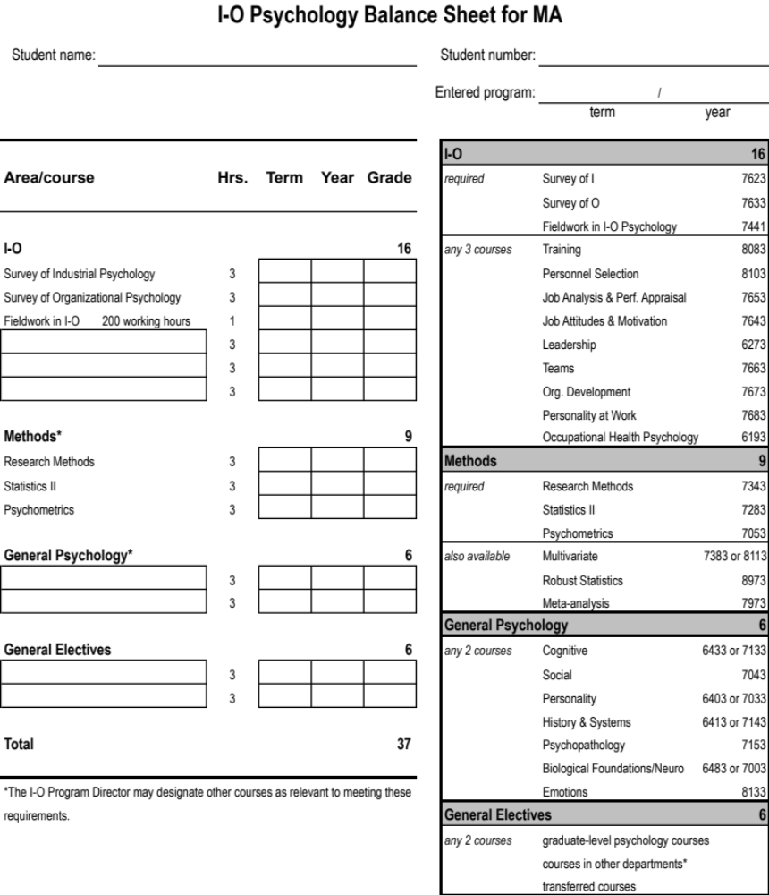

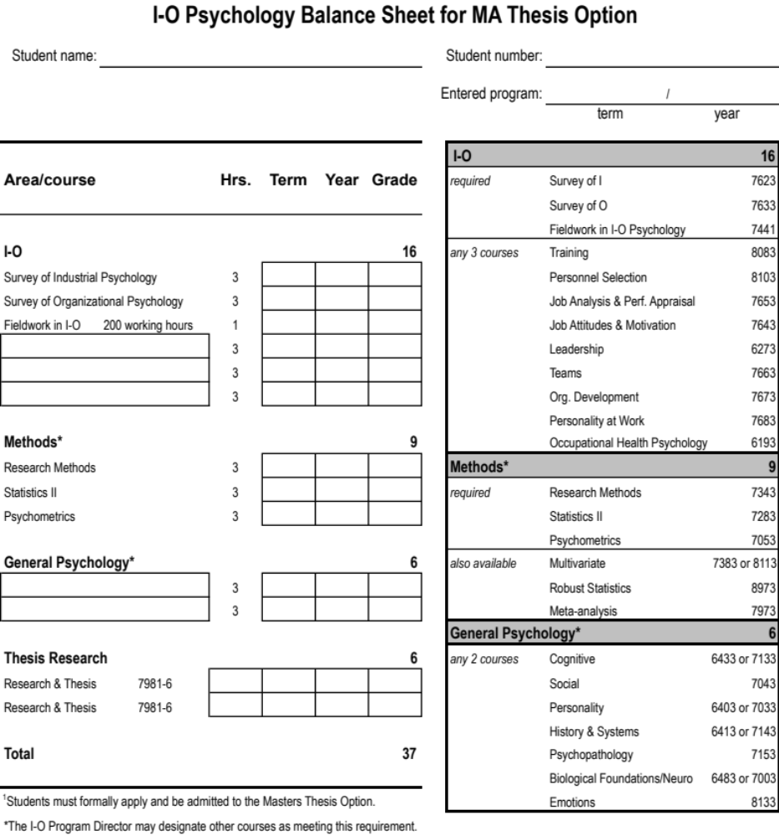
Thesis Requirements

Students may be admitted to the thesis option only after successfully completing at least 18 hours of degree-related coursework (usually at the end of year 1). As the thesis option is designed for exceptional students, applicants are expected to have earned (a) a minimum GPA of 3.66 from the first 18 hours of graduate-level coursework, (b) no grade below a B in those 18 hours (e.g., 4 A's, 2 B's), and (c) a grade of A in both Research Methods (PSY 7343) and Statistical Methods II (PSY 7283). In addition to the above information, the application should include a working research title and identify the primary faculty advisor. The application must be submitted to the I-O Program Committee no later than 1 year before the month in which the student plans to graduate (e.g., May 31 preceding the expected graduating year). Notice of acceptance or rejection is provided by the I-O Program Director within a reasonable timeframe (e.g., 2-3 weeks).

On acceptance, the student must (1) form a 3-person thesis committee, including the I-O faculty advisor, a second I-O faculty member, and a third TU graduate faculty member, by no later than the end of the first week of classes in the term preceding the expected graduating semester (e.g., late August of year 2); (2) successfully defend a thesis research proposal by the 13th week of classes in the term preceding the expected graduating semester (e.g., mid-November of year 2); and (3) complete and successfully defend the final thesis document by the end of the graduating semester (e.g., May of year 2). Guidelines for the thesis proposal and final document are provided below. Thesis option students who fail to meet the above requirements may be dismissed from the thesis option, but are encouraged to complete the basic I-O MA program. A form for tracking milestones is provided on p. 29.

Students admitted to the thesis option must abide by the corresponding balance sheet (see p. 26). Program requirements differ from the basic I-O MA in that 6 hours of general electives are replaced with 6 hours of thesis research. Students in the thesis option must enroll in at least 1 credit hour in each term during which a defense is held (e.g., 1 hour for the proposal defense, 2 hours for the thesis defense). As in the regular MA requirements, the total number of credit hours needed for graduation is 37 and MA comprehensive exams must be completed successfully. The exams are the same as those offered to regular MA students and are offered at the same time (usually, late January – early February of Year 2).

Guidelines for the Thesis Proposal and Final Document

As stated in the Graduate Bulletin,

Candidates must follow the guidelines for preparing a thesis set forth in “The Preparation of the Master’s Thesis and Doctoral Dissertation,” available in the Graduate School Office and on the Graduate School website. The thesis shall be presented before final submission to the Graduate School to the thesis committee in preparation for the thesis defense or oral examination.

The I-O MA thesis option is intended to develop research skills and mastery of a targeted content area within the broader I-O psychology domain. The scope of the research project will vary by student and by advisor. It is critical, however, that the thesis project be manageable within a one-year timeframe, which imposes limits on the length of the final document. An acceptable I-O thesis document will include one that is modeled after a journal submission, that is, between 20 and 30 pages of text (excluding cover page, abstract, references, tables, figures, and notes). Longer documents may be accepted, but students are urged to pursue submission of the resulting paper for presentation at a relevant professional conference (e.g., SIOP, AoM) and/or publication (conference presentation and publication are not requirements of the thesis option), where lengthy documents are less likely to be accepted. IRB approval must precede data collection and APA format is required for the final thesis document.

The thesis proposal should include the following: (a) thesis title, (b) abstract, (c) clear statement of the research problem, (d) review of the relevant literature(s), (e) explication of research hypotheses, (f) proposed data collection and analytic methods, and (g) likely implications of expected results. The proposal defense should be kept to 1 hour in length. It is designed not only to evaluate the merits of the proposed research, but also to improve design features toward ensuring successful thesis completion. The thesis final defense should not exceed 90 minutes and, at the discretion of the thesis committee, may or may not include an introductory presentation. Students are encouraged, but not required, to present their thesis research as part of the doctoral pre-candidacy day presentations, usually held in mid- to late-April.

Use of Archived Data

Students must be directly involved with data collection. Complete reliance on archived data (i.e., data collected by others and/or for purposes unrelated to the proposed research) would not satisfy this condition. Under no circumstances will complete reliance on archived data be judged acceptable. In cases where archived data are otherwise judged suitable (e.g., in addressing an important I-O research problem), the student must incorporate new data collection in one or both of two ways.

First, archived data may be augmented by data gathered by the student. The amount of new data deemed acceptable will depend on the nature of the research question, the need for increasing statistical power, and the availability of new data sources. The new data are expected to constitute at least 50% of the entire usable data. Exceptions must be clearly justified and documented.

Second, the student may gather judgments regarding targeted hypotheses. For example, if archived data are being used to assess the relationship between variables A and B, expert judgments could be gathered bearing on the direction of the AB relationship (i.e., positive vs. negative) or the effects of moderators. Data collection in such cases must contribute uniquely to answering targeted research questions and be formally incorporated into all key sections of the thesis document (i.e., introduction, methods, results, and discussion).

Use of Meta-analysis

Meta-analysis is an acceptable form of research for theses, provided that data collection is undertaken by the student. Data collection in meta-analysis entails coding of original published and unpublished sources (e.g., research articles, technical reports). In light of the policy on use of archived data (above), reliance on previously coded sources must be augmented by additional coding undertaken by the student (minimum 50% new) and/or collection of judgmental data bearing on targeted relations (e.g., in establishing directional hypotheses). Use of meta-analysis raises two additional issues.

First, sample size is an important consideration in any type of research because of its relation to statistical power, and any research question selected for a thesis must allow analysis using a sample size with adequate power. In meta-analysis, sample size derives from the number of available sources reporting a usable effect size (e.g., correlation). Accordingly, a thesis topic centered on meta-analysis will be considered viable only if sufficient original sources are available for the analysis. The number deemed sufficient will depend on the nature of the question. However, the minimum number of usable sources (i.e., independent samples) for a thesis meta-analysis is expected to be 30. Exceptions must be clearly justified and documented.

A second issue unique to meta-analysis is the file-drawer problem. Every reasonable effort is expected to be made to identify unpublished sources for a meta-analysis in order to rule out possible publication bias in mean effect sizes. Exceptions must be clearly justified and documented.

Use of Pre-Proposal Data

Students must prepare and present a thesis proposal for evaluation by the student’s thesis committee. Normally, it is in the student’s best interests to collect data only after the proposal has been successfully defended. In some cases, however, students may be permitted to use data collected prior to a successful proposal defense. Pre-proposal data may be included in a thesis study only if (a) delaying data collection until after the proposal defense would preclude its availability; (b) the thesis committee judges that the pre-proposal data adequately suit the stated research aims, and (c) the student was actively involved in data collection, as described above.

The second condition carries an important implication. Specifically, if the committee decides that a variable critical for answering a targeted research question was excluded, for any reason, from the pre-proposal data collection effort, the collected data may be judged unacceptable as the sole basis for the research. In such cases, the student may be required to collect additional data better suited to hypothesis testing. Collecting data prior to a successful proposal defense must therefore be considered a risk to be weighed carefully against the conveniences of pre-proposal data availability.

MA/JD Program

Purpose and Justification

The relationship between law and psychology is increasingly sophisticated and I-O psychologists must function in a complex legal environment. Further, psychological research often plays an important role in the development and enforcement of legal regulations. Finally, organizations rely on both lawyers and I-O psychologists to develop organizational systems and resolve personnel conflicts. The University of Tulsa developed the joint MA/JD program to respond to these issues. The joint MA/JD program is designed for law students interested in understanding the psychological principles that guide organizational behavior and personnel management, the scientific methods that promote social fairness in the workplace, and the legal defensibility of various organizational interventions. (Source: Adapted from Law school Document on Joint Law Degree Programs)

Program Requirements

The joint MA/JD curriculum consists of 111 credits. Students must complete 78 semester hours of law courses including all required subjects as established by the College of Law. Students also must complete 31 hours of I-O psychology courses as defined by the I-O balance sheet for the MA/JD program. The remaining three credits may be taken either in law or psychology (at the student’s discretion). Students do not have to make an official decision concerning which program they will take the final three credits in until they actually take the credits (law school requirements may vary).

How are admissions decisions made?

The law and MA programs make separate admission decisions. Admission into the MA program does not guarantee admission into the law program. Similarly, admission into the law program does not guarantee admission into the MA program. Students must go through the regular application process for each program. Since the admission criteria vary between the programs, joint program applicants must meet all of the admissions criteria established by each program.

How is the joint program administered?

The I-O program supervises the student’s education in the I-O program and the law school supervises the student’s Law School education. However, joint degree students should enroll in all courses on a Law School enrollment card. Further, students must obtain Graduate Advisor and Graduate School approval for all courses taken for the MA portion of the joint program. This approval is indicated by the appropriate signatures on the enrollment card. Students are required to take the normal first year law curriculum during their first year. After successful completion of the first year, students meet with advisors from each program to plan the remainder of their academic program. Directors of the I-O and JD programs recommend the following policy:

Students in the joint program are permitted to terminate plans for a joint degree and to opt for a degree in either law or the complementary discipline. Students will be obliged to satisfy the normal requirements of the college selected, which may include credit for some work done in the other college as determined by the Dean of the College of Law or…the Graduate School.

After being admitted to the MA program can I switch to the joint program?

Yes. Students who were originally admitted to the MA program take one of two routes to switch programs. First, some students choose to complete the standard MA curriculum and then apply for admission into law school. In this case the two programs are considered to be completely distinct and students are required to meet the full requirements of each program. Second, students may decide during their MA program, to apply to the joint program. In these cases, students are permitted to take the reduced load - subject to the approval of both programs. In either case, students must complete the normal admissions process for the law school but do not need to reapply to the I-O program.

The MA/JD Balance Sheet

The following page describes the program requirements for the MA/JD program.

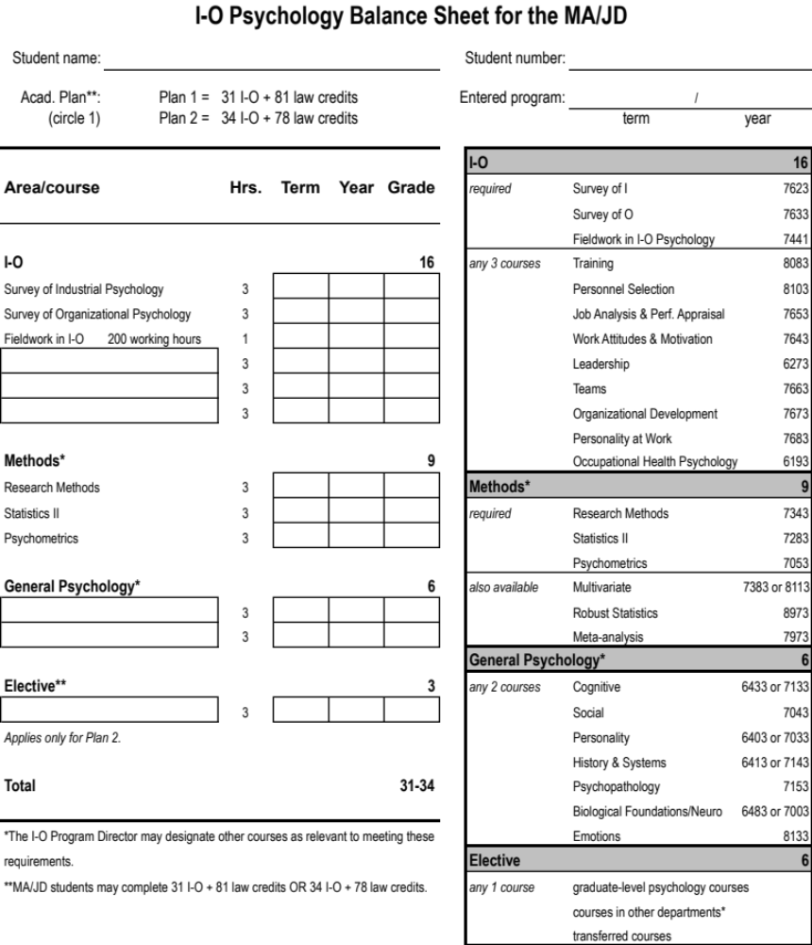

MA Comprehensive Examination

Overview

The purpose of the Masters comprehensive examination is to create a “capstone assessment” of students’ possession of (1) an understanding of the science and practice of I-O psychology and (2) the practical, analytic, and communication skills necessary to apply I-O knowledge to solve practical problems in organizations. The exam thus offers a reasonable snapshot of MA student learning, affording opportunity for timely feedback on strengths and developmental needs and serving as a key quality-control device that helps protect the integrity of the I-O program. The exam is offered once per year, on the Friday before the start of Spring semester classes; but may be offered at other times during the year, at the discretion of the I-O Program Committee.

Students intending to take the Masters comprehensive exam must inform the I-O Program Director in writing (e-mail preferred) at least 8 weeks prior to the scheduled date of the exam (usually by late October). Also, students must be enrolled in the semester in which they take the exam.

Exam Components

The Masters comprehensive examination has three parts: (1) written, (2) analytic, and (3) oral components. All 3 components are completed within a one- to two-week time period. Components 1 and 2 are administered on the same day (written exam in the morning, analytic exam in the afternoon), and students must pass both Parts 1 and 2 before being permitted to complete Part 3 (oral exam).

In Part 1, the written component, the student must answer 7 “short answer” questions derived from the following 12 core competencies for I-O psychologists (source: SIOP, 2016; see p. 23 for a complete list of all I-O competencies):

- Ethical, Legal, Diversity & International Issues / Professional Skills (mandatory)

Industrial Psychology (3 of the following)
- Criterion Theory & Development / Human Performance
- Job/Task/Work Analysis/Competency Modeling & Classification
- Personnel Recruitment, Selection & Placement
- Performance Appraisal & Management
- Training: Theory, Delivery, Program Design, & Evaluation

Organizational Psychology (3 of the following)
- Work Motivation
- Leadership & Management
- Attitude Theory, Measurement, & Change
- Groups & Teams
- Organizational Theory / Organizational Development
- Occupational Health & Safety

Students will answer a single question from the Ethical, Legal, etc. domain, and 3 questions from each of the Industrial Psychology and Organizational Psychology domains. Answering the first question (on ethics, etc.) is mandatory, and the 2 sets of 3 permit selection from among 5 and 6 alternative questions (Qs 2 - 6 and 7 - 12), respectively.

A comprehensive reading list will not be provided for these topics. A partial reading list is available, however, on Harvey/WebCT, organized by content area. It is the student's responsibility to identify and review the relevant, important information in preparation for taking the exam. Students’ answers should reflect the state of the literature, but citations are not required. In general, students are expected to be familiar with material covered in TU I-O psychology courses. All questions are designed to be answerable by the minimally qualified MA student in approximately 15 minutes per question. The exam is closed-book, and students have 2 hours to complete Part 1.

Part 2 of the exam, the analytic component, is designed to assess students’ abilities to work with data and interpret results in light of applied problems in organizational settings. Part 2, offered on the same day as Part 1, is designed to tap the following 3 core competencies for I-O psychologists (source: SIOP, 2016):

- Research Methods
- Statistical Methods/Data Analysis
- Individual Differences (Psychometrics & Scale Development)

Working at an appropriately equipped computer station (i.e., with SPSS, MS Word, and e-mail functionality), the student will be presented with an organizational scenario describing a realistic problem relevant to I-O psychology, and a corresponding set of questions. An SPSS data file is provided, and students must apply their knowledge of analytical procedures to diagnose the organization’s problems via SPSS data analysis, and answer the specific questions provided. Within a 3-hour time limit, students will submit an SPSS output file (edited to remove unwanted analyses) and a brief report directed to the company, outlining the problem and describing appropriate results, interpretations, and proposed interventions using language suited to the hypothetical client. Students may access any source materials on-line or that they bring with them to the exam (i.e., it is an “open-book” exam). The only information sources off limits for this exam are real-time, real-world people (i.e., no live contact with a methods, statistics, and/or psychometrics consultant of any level of expertise is permitted during the exam).

Part 3 of the exam, the oral component, is designed to assess the individual student's abilities to communicate verbally and defend responses provided in Parts 1 and 2. Specifically, with regard to the analytic component, students may be asked to deliver a brief, informal report to the hypothetical company, outlining the problem and describing appropriate results, interpretations, and proposed interventions. The number and nature of questions asked may vary from student to student, but it is generally expected that each rater will be allowed as many questions as he or she deems necessary to judge the targeted competencies. The format of the oral exam is generally unstructured, except that students are asked at the beginning to address specific errors or weaknesses they themselves identified after completing Parts 1 and 2. The maximum time allowed for this portion of the exam is 5 minutes. Students are not expected to review every answer and every limitation detected. Rather, the focus should be on the just the bigger issues. The oral exam will typically be scheduled a week after the written and analytic components (to allow time for preparation of appropriate questions), and the order of students’ exams will be determined by random draw in light of students’ prior schedules.

Grading

At least two members of the I-O Program Committee grade all parts of each student’s exam using evaluative criteria specific to each component, as described below. An additional member will serve as an independent "tie-breaker" when one or both of the two initial raters fails the student on a single question, in the case of the written exam, or the overall exam component.

Part 1: Written
The following criteria apply in grading each of the 7 written exam answers:

- quality of content (i.e., brings relevant information to bear in answering the question; excludes irrelevant material; stays on track);
- comprehensiveness (i.e., addresses all parts of the question in proportion to importance and relevance); and
- quality of written communication (i.e., grammar, spelling, word choice, organization and flow, transitions, precision, concision).

In light of all criteria, each rater independently grades each item using the following evaluative system:

3 = High Pass Clearly beyond typical student performance expectations
2 = Pass Consistent with typical performance expectations
1 = Weak Pass Minimally acceptable; key point missed or poorly communicated
0 = Fail Questions left unanswered or otherwise unacceptable in content or quality of
communication

Points are averaged across questions and raters to derive an overall score judged in terms of the following overall evaluative system for the written exam:

Exemplary 2.5 - 3.0
Satisfactory 1.5 - 2.4
Unsatisfactory 0.0 - 1.4

Part 2: Analytical

All questions in this component are designed to allow objective scoring in terms of relative correctness. Evaluative criteria include, but are not limited to:

- appropriateness in choice of methods (i.e., selected statistical procedures are suited to determining the nature of the problem and identifying possible interventions);
- completion of methods (i.e., selected statistical procedures are performed accurately, such that output permits valid and complete interpretations in light of the given problem);
- interpretation of output (i.e., results are interpreted accurately and completely in light of the targeted problem and limitations); and
- communication of results (i.e., written feedback to the company is suitably worded and presented in appropriate detail; results are graphed appropriately).

In light of all criteria, each rater independently grades the entire set of items using the following evaluative system:

Exemplary 2.5 - 3.0
Satisfactory 1.5 - 2.4
Unsatisfactory 0.0 - 1.4

The overall analytical grade, per judge, may reflect a global rating based on all answers collectively or the average of individual question scores based on the 0-3 scale described above for the written exam (i.e., 0 = Fail, etc.) (A minimum overall grade of 1.5 is required to pass the analytic exam; see two criteria, below).

Part 3: Oral

Prior to conducting oral exams for a given cohort, the designated examiners meet to identify key targets for evaluation relevant to the entire cohort (i.e., based on shared weaknesses) and on a student-by-student basis. Of particular interest are topics all students are expected to have mastered that one or more students show lack of mastery in the written and/or analytic components (e.g., how analysis of variance works, sampling error vs. measurement error, moderation vs. mediation). The following criteria apply to the entire set of oral exam questions:

- quality of content (i.e., understands the question and responds directly to it; brings relevant material to bear in answering the question; avoids irrelevant or tangential issues; stays on track);
- comprehensiveness (i.e., addresses all parts of the question in proportion to importance and relevance);
- quality of oral communication (e.g., grammar, clarity of speech, organization and flow, avoids “ums” and “ahs”; avoids interrupting; is pleasant and professional in speech); and
- quality of nonverbal communication (i.e., gestures, facial expressions, and body posture are appropriate to the question and response).
Criteria (c) and (d) may be weighted less in light of certain disabilities but only if formally documented with TU student services.

In light of all criteria, each rater independently grades the entire set of oral responses, judged collectively, using the following evaluative system:

Exemplary 2.5 - 3.0
Satisfactory 1.5 - 2.4
Unsatisfactory 0.0 - 1.4
There are two criteria for passing the comprehensive exam, as follows:

1. Minimum of 1 (“weak pass”), averaging across raters, on each of questions 1 to 7 in Part 1 (written exam).
2. An overall score, averaging across raters, at or above Satisfactory (i.e., 1.5) on each of the three components.

Failure

Students with unsatisfactory performance on any component of the exam, as defined above, are considered to have failed that component of the exam. Such students are required to retake the failed component(s) at a later time, as determined by the I-O Program Committee in light of the student's perceived developmental needs. Students who fail either or both the written and analytic components (which are offered on the same day) must pass a second version of the failed component(s) (i.e., a new exam intended to be of equal overall difficulty) before taking the oral exam. Students who fail the oral component must re-take that component as well. Typically, students who fail a given component on the first attempt retake that component later in the same semester, following a time period judged suitable to permit adequate preparation. This preparatory interval may vary from student-to-student, but is generally expected to be at least 8 weeks in length.

Students are allowed to fail and retake each component of the exam only once. Those who fail the same component twice will not be awarded a Masters degree. Doctoral students taking the MA-level exam as stage 1 will not be permitted to continue in the doctoral program.

Conditional Pass

For students who demonstrate specific skill deficiencies in any part of the exam, including the oral component, the I-O Program Committee may assign additional written remedial questions targeting those deficiency areas, under a “conditional pass.” The deadline on such "take-home" remedial assignments will be determined on an ad hoc basis, but will generally fall between 2 and 4 weeks from the day the assignment is given. Remedial assignments are to be completed solely by the student, and will be graded by at least 2 members of the I-O Program Committee. A third member will serve as an independent "tie-breaker," if necessary.

Students will have only one opportunity to complete a remedial assignment. Unsatisfactory performance on such an assignment will constitute failure of the component. Completing a remedial assignment following an unsuccessful regular exam component does not preclude retaking that component, unless the student has not passed the component already on two attempts.

It should be noted that the I-O Program Committee makes every reasonable effort to ensure that all exam questions are fair in representing key I-O content and/or methods as well as in terms of expected performance levels (as per the noted grading criteria). The Committee avoids a "trial-by-fire" mentality in preparing the exam, targeting instead a level of difficulty allowing primary differentiation between unqualified and minimally qualified performance. The Committee recognizes the subjectivity of this criterion, but brings a collective diversity of knowledge, skills, and interests to bear in reaching a generally shared and defensible understanding of student exam performance benchmarks.

V. Doctoral Program in Industrial-Organizational Psychology
_________________________________________________________________________________________________________________

Student Progress Benchmarks & Timeline

The I-O program takes a keen interest in the speed and quality of each student’s progress. In this context, the following benchmarks are presented as guidelines for advancement. These benchmarks also form the basis of the program's assessment of doctoral students’ performance throughout the program. Notably, the primary distinction between the MA and Ph.D. programs is a relative emphasis on research, evidenced by (1) the pre-candidacy project, (2) credit hours designated for research (max = 25), and (3) the dissertation.
__________________________________________________________________________________________

By the end of this year... Ph.D. students are expected to have . . .
__________________________________________________________________________________________

FIRST YEAR successfully completed 18-21 credits of coursework/research
Fall: Survey of I, Research Methods, Statistics
Spring: Survey of O, Psychometrics, 1 other course
Summer: Internship (optional)
pre-candidacy research started

SECOND YEAR successfully completed 36-42 credits of coursework/research
Fall: Personnel Selection, 2 other courses/research/internship
Spring: Stage 1 comprehensive exams (= MA comps)
3 courses/research/Internship
pre-candidacy research and presentation
Summer: Internship (optional)

THIRD YEAR successfully completed 54-63 credits of coursework/research
Fall: 3 courses/research/Internship
Spring: Stage 2 comprehensive exam (written)
3 courses/research/Internship
dissertation proposal started
Summer: Internship (optional)

FOURTH YEAR successfully completed 72-84 credits of coursework/research
Fall: 3 courses/research/Internship
doctoral chair and committee assembled
Dissertation Proposal Meeting
applied for admission to doctoral candidacy
applied for a Bellwether Fellowship (due Dec. 1)
Spring: 3 courses/research/Internship
Dissertation work started, including data collection
Summer: Internship (optional)

FIFTH YEAR successfully completed all 90 credits of coursework/research
Fall: 3 courses/research/Internship
Spring: 3 courses/research/Internship
defended and completed the Dissertation

Procedural Notes:

- Total credit hours = 90; up to 25 may be for research, including dissertation; 65 are non-research.
- The Stage 2 comprehensive exam is offered only after successful completion of both the Stage 1 (MA-level) exam and the pre-candidacy project.
- If the dissertation proposal is not completed within at least two years of completion of comprehensive exams, the student may be required to re-take comprehensive exams prior to the dissertation proposal.
- Students are not allowed to enroll for dissertation credits until admitted to doctoral candidacy.
- Students must be enrolled in at least one TU credit during any semester in which a major academic milestone is completed (e.g., comprehensive exams, dissertation proposal, dissertation defense).

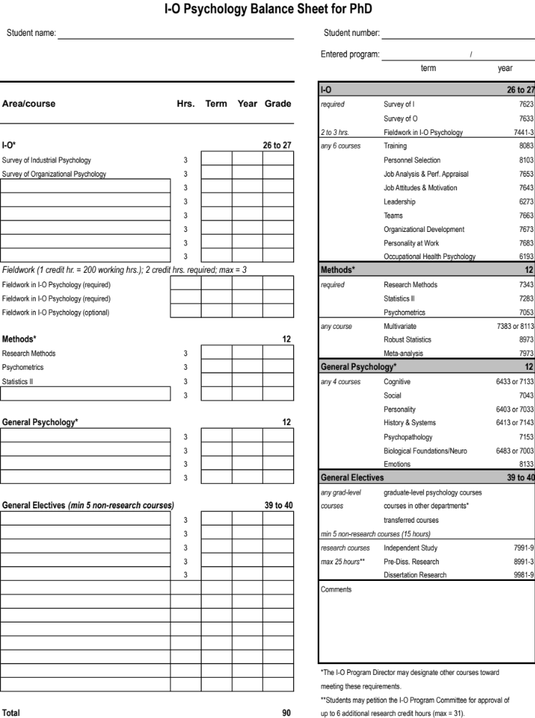

Pre-candidacy Paper

Overview

Prior to admission to candidacy, the I-O program requires each doctoral student to complete an independent research project. This project promotes early involvement in research, facilitates the development of special expertise, and ensures that students receive research mentoring by faculty members. The pre-candidacy project also prepares students for their dissertation research.

Performance Standards

The pre-candidacy paper requires the student to complete a significant research project on a topic in I-O psychology. Students who are unclear about the content domain of I-O psychology should review the I-O Psychology Core Competencies described earlier. Students are expected to review literature, analyze and interpret data, and write the paper. Specific standards for the paper are left to the discretion of the faculty advisor. A typical standard is that the project should be of sufficient quality to be presented at a national or regional academic conference.

Archival and/or collaborative research projects are acceptable. Further, many pre-candidacy projects result in co-authored presentations at national/regional conferences. However, students should note that they are expected to play a significant and active role in all phases of their research project. For instance, hiring a statistical consultant to analyze the data would be no more appropriate than would hiring a ghostwriter. Finally, minor contributions such as collecting data for a faculty member may warrant authorship on a conference paper but would not meet the requirements of the pre-candidacy project.

Who must complete a pre-candidacy paper?

All I-O doctoral students must complete a pre-candidacy paper. Masters’ theses or other independent research projects may be substituted for the pre-candidacy paper at the discretion of the I-O Program Committee. Research conducted while the student was an undergraduate may not be used to meet this requirement. Finally, participation in research provides students with skills that are valued by employers (written communication, data management, oral presentation, library research, etc.). Thus, the I-O program strongly encourages students to become involved in research projects regardless of whether the specific project meets a program requirement.

Procedures

During the first year of graduate study, students should select an advisor and begin work on the project. Students are not assigned to research advisors. Rather, students and advisors mutually agree to work on a specific project. Students may choose any member of the psychology department to supervise their pre-candidacy research, provided that the subject matter of the paper is within the content domain of I-O psychology. When the project is completed, the student is expected to notify the I-O Program Director. Students are required to submit the actual paper to the I-O Program Director to be placed in their permanent file. Finally, the pre-candidacy project must be completed before the student takes the Ph.D. comprehensive exam.

Pre-Candidacy Paper Presentation

The pre-can requirement has two components: (1) the actual written paper and (2) the pre-candidacy presentation. As described above, the form of the written paper is at the discretion of the supervising faculty member. However, all students must present their research at Pre-candidacy Day. Pre-candidacy day is held at least once each academic year (generally in the Spring). This meeting consists of public presentations by I-O and Clinical students that describe their pre-candidacy research. Individual presentations are typically limited to 15 minutes and are expected to be of professional quality. Students may not take the I-O comprehensive examination until they have completed this presentation.

Doctoral Comprehensive Examination

Overview

The purpose of the doctoral comprehensive examination is twofold. First, it offers a “midpoint assessment” of the depth and breadth of students’ understanding of I-O psychology content and methods in application to the science and practice of I-O psychology. The 2-stage exam (see below) is offered at the start of the Spring semester of the doctoral student's second and third years. Although falling approximately halfway through the 5-year program of study, most coursework credits are expected to have been completed. The exam thus offers a reasonable snapshot of student learning, affording opportunity for timely feedback on strengths and developmental needs and serving as a key quality-control device that helps protect the integrity of the TU doctorate in I-O. Second, preparing for comprehensive exams leads the student to consolidate and integrate substantial amounts of learning for application in research and practice on graduation as well as in meeting the rigors of the dissertation. This is especially true given the special topic question (see below), designed explicitly to lay a foundation for dissertation research in a selected domain.

The I-O Doctoral comprehensive exam is administered in two stages. Stage 1 is equivalent to the I-O MA comprehensive exam, including its three components (written, analytic, oral; see pp. 31-34) and its scheduling. Stage 2 is a doctoral-level written exam requiring responses to four questions. Three of those four questions are selected as of one two options in each of three main topic areas: Industrial Psychology, Organizational Psychology, and Research Methods (see p. 23 for all competencies listed per domain). The fourth question covers a student-selected special topic, described separately, below. Further, any or all questions can include coverage of General I-O competencies (e.g., ethical, professional issues; individual assessment; see p. 23).

Passing the Stage 1 exam is required before the Stage 2 exam is offered. (The pre-candidacy project must also be completed.) The Stage 2 exam is offered a year following the Stage 1 (MA-level) exam, also on the Friday before the start of Spring semester classes. Students intending to take the Stage 2 doctoral comprehensive exam must inform the I-O Program Director in writing (e-mail preferred) at least 8 weeks prior to the scheduled date of the exam. Students must be enrolled in each semester in which they take a given exam.

Special Topic Question. Each Stage 2 examinee will be given an “expertise” question written by the student’s primary research advisor, covering a selected area of expertise. Special topics tend to be more specific than any of the core areas and must be clearly within the scope of I-O psychology (e.g., personality and job performance, leader-member exchange, organizational commitment, validity generalization, legal issues in employee selection). The student develops a reading list for his or her special topic in collaboration with the primary advisor. Expected to serve as a foundation for the student's dissertation, the list should include 30-50 important and influential published sources representing the targeted area in both breadth and depth. Overlap among sources is to be minimized (e.g., articles by the same author on highly related content), and balance should be achieved between historical and current thinking, between broad and narrow coverage (e.g., I-O Handbook chapter vs. focused research papers), and between theoretical and practical orientations (as appropriate for the selected topic). The list is expected to be organized into subsections and must be approved by the I-O Program Committee no later than 4 weeks prior to the scheduled exam date. Students are urged to submit the list for Committee review at least 6 weeks ahead of the exam date to allow opportunity for any needed revisions.

Students will have 6 hours to complete Stage 2 (3 hours in the morning and 3 hours in the afternoon) and will be expected to cite the relevant literature in answering all four questions. The exam is closed-book, but examinees may bring a list of up to 100 references with them to aid in citations. In general, students also are expected to be familiar with material covered in TU I-O psychology courses (and/or their equivalents taken at other institutions). A partial reading list is available on Harvey/WebCT, organized by content area.

Grading

At least two members of the I-O Program Committee grade each answer using the same evaluative criteria employed in grading the Stage 1 (MA-level) written exam (see pp. 32-34). This includes the criteria of (1) a minimum of 1 (“weak pass”), averaging across raters, on each of questions 1 to 4, and (2) an overall score, averaging across raters and questions, at or above Satisfactory (i.e., 1.5). An additional member may serve as an independent "tie-breaker" when one or both of the two initial raters fails the student on a single question, and/or the overall score falls below 1.5.

Failure

Students failing to meet the stated standards are required to retake the Stage 2 exam at a later time, as determined by the I-O Program Committee in light of the student's perceived developmental needs. The preparatory interval may vary from student-to-student, but is generally expected to be at least 6 weeks in length.

Students are allowed to fail and retake the Stage 2 exam only once. Those who fail the exam twice will not be awarded the doctorate.

Conditional Pass

For students who demonstrate specific skill deficiencies in the Stage 2 exam, the I-O Program Committee may assign additional written remedial questions targeting those deficiency areas, under a “conditional pass.” The deadline on such "take-home" remedial assignments will be determined on an ad hoc basis, but will generally fall between one and four weeks from the day the assignment is given. Remedial assignments are to be completed solely by the student, and will be graded by at least two (2) members of the I-O Program Committee. A third member will serve as an independent "tie-breaker," if necessary.

Students will have only one opportunity to complete a remedial assignment. Unsatisfactory performance on such an assignment will constitute failure of the Stage 2 exam. Completing a remedial assignment following failure on the Stage 2 exam does not preclude retaking the exam, unless the student has failed the exam on two attempts.

It should be noted that the I-O Program Committee makes every reasonable effort to ensure that all exam questions are fair in representing key I-O content and/or methods as well as in terms of expected performance levels (as per the noted grading criteria). The Committee avoids a "trial-by-fire" mentality in preparing the exam, targeting instead a level of difficulty allowing primary differentiation between unqualified and minimally qualified performance. The Committee recognizes the subjectivity of this criterion, but brings a collective diversity of knowledge, skills, and interests to bear in reaching a generally shared and defensible understanding of student exam performance benchmarks.

Doctoral Dissertation

Overview and Purpose

The doctoral dissertation is the culmination of the Ph.D. degree. It should reflect maturation of skills involved in understanding, applying, and advancing knowledge in psychology. The dissertation is based on original research and requires the student to demonstrate research skills; acquire in-depth knowledge of a specialty area in I-O psychology; and integrate theory, empirical findings, and applications in psychology. Although the student is responsible for all portions of the work, the doctoral committee and especially the doctoral chair offer advice and assistance and must approve both the proposed and completed project.

Guidelines for Acceptable Dissertations

Dissertations must be prepared according to the requirements of the Graduate School as described in the Dissertation Guide publications and written according to the standards of the most recent edition of the Publication Manual of the American Psychological Association. The Dissertation Guide states that,

The graduate student preparing a thesis or dissertation is responsible for: selecting a research area; conducting a thorough search in a related literature; defining a research problem; selecting methods of investigation and research; developing investigative techniques and methods; evaluating results of investigations; and preparing the thesis or dissertation. The student is solely responsible for the form, clarity, proper use of English, and other details (p. 2).

The steps outlined above are useful but generic. In an effort to clarify what is expected specifically of I-O doctoral students regarding their dissertation research, the I-O faculty has further articulated the steps required in preparing a dissertation, as follows.

An I-O psychology graduate student preparing a dissertation is responsible for each of the following:

a) selecting a research area relevant to I-O psychology;

b) conducting a thorough search of the appropriate literature(s);

c) defining a research problem with justification of its importance to the theory and/or practice of I-O psychology;

d) preparing a thorough summary of the literature as it bears on the research problem (e.g., others’ rationales, prior findings, methodological issues);

e) specifying testable research hypotheses (directional if possible);

f) selecting and/or developing appropriate methods of investigation and research (e.g., experimental design, test development, data collection, data analytic procedures);

g) collecting usable, quantitative data from appropriate populations in sufficient amounts to allow adequate statistical power;

h) analyzing the data statistically in testing the research hypotheses;

i) interpreting results of the data analysis in light of the research hypotheses (i.e., internal validity);

j) drawing valid inferences in light of the targeted research problem and populations (i.e., external validity); and

k) preparing the dissertation document as a self-contained, technically thorough, up-to-date, and readable contribution to the targeted literature (publication of a briefer version in a professional outlet may be a worthwhile goal, but is not required).

Each step is a necessary condition for meeting the dissertation requirement. Broader procedural steps (e.g., regarding proposal preparation and defense) are described on pp. 46-48 of this Handbook.
Use of Archived Data

Condition (g) specifies that the student must be directly involved with data collection. Complete reliance on archived data (i.e., data collected by others) would not satisfy this condition. In cases where archived data are otherwise judged suitable (e.g., in addressing an important IO research problem), the student must incorporate new data collection in one or both of two ways.

First, archived data may be augmented by data gathered by the student. The amount of new data deemed acceptable will depend on the nature of the research question, the need for increasing statistical power, and the availability of new data sources. The new data are expected to constitute at least 50% of the entire usable data. Exceptions must be clearly justified and documented. Under no circumstances will complete reliance on archived data be judged acceptable under condition (g).

Second, the student may gather judgments regarding targeted hypotheses. For example, if archived data are being used to assess the relationship between variables A and B, expert judgments could be gathered bearing on the direction of the AB relationship or the effects of moderators. Data collection in such cases must contribute uniquely to answering targeted research questions and be formally incorporated into all key sections of the dissertation document (i.e., introduction, methods, results, and discussion).

Use of Meta-analysis

Meta-analysis is an acceptable form of research for dissertations, provided all conditions are met, including condition (g). Data collection in meta-analysis entails coding of original published and unpublished sources (e.g., research articles, technical reports). Under condition (g) and in light of the policy on use of archived data (above), reliance on previously coded sources must be augmented by additional coding undertaken by the student (50% new) and/or collection of judgmental data bearing on targeted relations (e.g., in establishing directional hypotheses). Use of meta-analysis raises two additional issues.

First, sample size is an important consideration in any type of research because of its relation to statistical power, and any research question selected for a dissertation must allow analysis using a sample size with adequate power, as per condition (g). In meta-analysis, sample size is the number of available sources reporting a usable effect size (e.g., correlation). Accordingly, a dissertation topic centered on meta-analysis will be considered viable only if sufficient original sources are available for the analysis. The number deemed sufficient will depend on the nature of the question. However, the minimum number of usable sources (i.e., independent samples) for a dissertation meta-analysis is expected to be 50. Exceptions must be clearly justified and documented.

A second issue unique to meta-analysis is the file-drawer problem. Every reasonable effort is expected to be made to identify unpublished sources for a meta-analysis in order to rule out possible publication bias in mean effect sizes. Exceptions must be clearly justified and documented.

Use of Pre-Proposal Data

As described below, students must prepare and present a dissertation proposal for evaluation by the student’s dissertation committee. Normally, it is in the student’s best interests to proceed with data collection only after the proposal has been successfully defended. In some cases, however, students may be permitted to use data collected prior to a successful proposal defense. Pre-proposal data may be included in a dissertation study if (a) delaying data collection until after the proposal defense would preclude its availability; (b) the dissertation committee judges that the pre-proposal data fully suits the goals of the research, and (c) all other conditions bearing on data collection are met (e.g., the student was actively involved in data collection, as described above).

The second condition carries an important implication. Specifically, if the committee decides that a variable critical for answering a targeted research question was excluded, for any reason, from the pre-proposal data collection effort, the collected data may be judged unacceptable as the sole basis for the dissertation. In such cases, the student may be required to collect additional data better suited to hypothesis testing. Collecting data prior to a successful proposal defense must therefore be considered a risk to be weighed carefully against the conveniences of pre-proposal data availability.

Procedures and Phases

The doctoral dissertation has six procedural phases.

Phase I: Development of the Dissertation Proposal
The dissertation proposal serves two purposes. First, the process of developing the proposal should encourage the student to give careful thought to all phases of the study, from conceptual development to data collection and analysis. Second, because the advisor and the doctoral committee (see below) must approve the proposed research, it is expected that the committee will reach consensus on the nature and scope of the project prior to its implementation.

The dissertation proposal consists of a written paper proposing an original research project. The paper should develop the theoretical rationale for the project, describe the expected participants in the study, present a detailed description of research methods including data gathering procedures, research instruments, and intended data analytic strategies. Students are encouraged to keep the proposal narrowly focused and as close to the format of the final dissertation as possible. Typically, the proposal consists of the first three chapters of the dissertation: the introduction, the literature review, and the method section.

The flow chart on the next page depicts the dissertation proposal process. The student works closely with the doctoral committee chair during proposal development. Students should clarify the expectations of other committee members during proposal development but the doctoral advisor usually tentatively approves the proposal draft before other committee members read it.

Phase II: Assembly of Doctoral Committee

Near the beginning of proposal development, the student and doctoral committee chair identify possible committee members from eligible candidates. Details on committee requirements are provided on p. 48. Members should possess relevant expertise and/or perspectives to qualify them as judges of the dissertation proposal and final document. Committee members must also be available during the course of the research (at least at critical periods) to serve as advisors and evaluators. Individuals identified as suitable committee members serve at their discretion; they are not required to serve when asked. Communications regarding research planning are encouraged by any of the usual media; participation in proposal and final defenses is preferred in person but may be engaged by phone.

Committee members generally expect to be given a minimum of two weeks to review the proposal prior to the scheduled defense date. Accordingly, committee formation should be completed by no later than two weeks before the defense date. Typically, committees are formed much earlier, e.g., 6-9 months before the proposal defense.

Phase III: Dissertation Proposal Meeting
Once committee members tentatively approve the proposed study, the student should schedule a formal dissertation proposal meeting. The purpose of this meeting is for the student and the committee to reach consensus on the nature and scope of the project. Proposal meetings typically have the following components:

1. Brief introduction by the advisor.
2. Short (15-25 minutes) formal presentation of the rationale for the project by the student.
3. Examination of the proposal by the committee.
4. Evaluation of the dissertation proposal by the committee.

Generally, the proposal meeting results in one of three outcomes:

1. Full Approval of the project.
2. Conditional Approval - where committee members request changes prior to awarding final approval.
3. Non-approval – the proposal is not approved when the student does not display sufficient understanding of relevant issues, is unable to present a convincing rationale for the project, or where substantial changes to the design or conceptualization of the project are required. An additional proposal meeting is typically required.

When all members of the committee have given final or conditional approval for the project, the student should complete and file the Dissertation Proposal Approval Form - see p. 49.

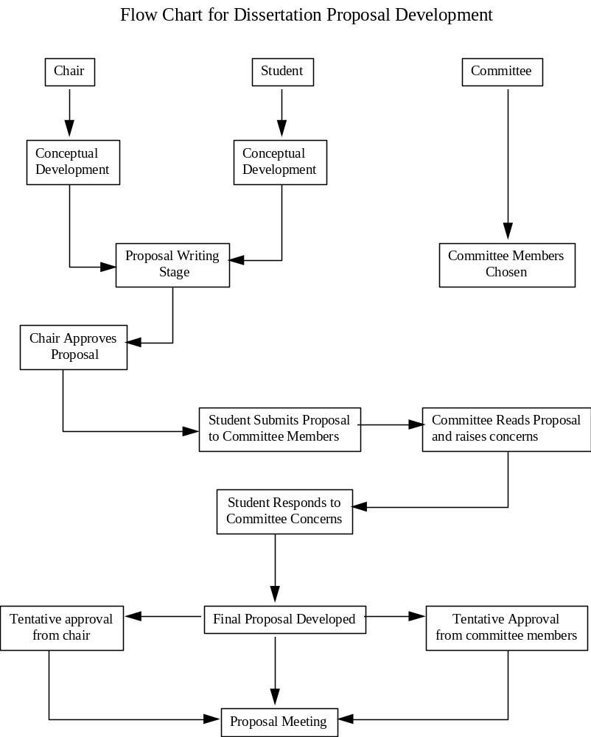

Phase IV: Admission to Candidacy
On successful completion of the student’s proposal defense, the doctoral committee chair formally requests from the Graduate School that the student be admitted to doctoral candidacy. The student is sent an Application for Admission to Candidacy form. See p. 50 for further details.

Phase V: Dissertation Research and Preparation of the Dissertation Document

Once formally admitted to doctoral candidacy, the student carries out the research described in the proposal and writes up the final dissertation document. Adding to the first three chapters (introduction, literature review, and methods) are chapters targeting results (4) and discussion of findings (5). Other chapter arrangements are viable; e.g., in the case of multiple studies, each study might warrant its own chapter, complete with methods, results, and interpretations. The aim in all cases is to present all relevant sections so as to maximize their understandability and avoid unnecessary redundancies. The student works with the Doctoral Committee Chair to determine the most reasonable organization of the dissertation document, as well as its scope and content.

If proposed steps cannot be undertaken (e.g., targeted subject samples of sufficient size are unavailable), the student should work with the committee chair (i.e., main advisor) and relevant committee members to identify alternative strategies. Any substantial changes from the proposed research aims and/or methods should be related to all committee members at the earliest opportunity. Especially large changes may require that a new proposal be prepared and defended. Such decisions fall to the doctoral committee as a whole and are very rare.

Students should prepare their dissertation documents according to the guidelines provided by the Graduate School. Failure to do so may require reformatting, possibly delaying graduation by one semester (if close to the document submission deadline for graduation).

Phase VI: Dissertation Defense Meeting
The final stage in the project is the Dissertation Defense Meeting, which is held only when each member of the doctoral committee has read and tentatively approved the dissertation. This meeting is similar in structure to the dissertation proposal meeting with the same potential outcomes. Committee members signify their approval of the project by signing the cover page of the completed dissertation manuscript. The completed and signed manuscript is then submitted to the graduate school for final approval.

Doctoral Chairs and Committees

Responsibilities of the Doctoral Chair and Doctoral Committee

The doctoral chair assumes primary responsibility for advising the student. This includes (a) directing the student's research efforts, (b) encouraging appropriate professional experiences, (c) determining what constitutes an acceptable pre-candidacy paper, (d) structuring appropriate academic and professional development to better prepare the student for the various stages of the dissertation, and (e) serving as an appropriate role model.

The doctoral committee’s primary responsibilities are to (1) read and judge the adequacy of the dissertation proposal in a formal meeting, (2) read and evaluate the readiness of the dissertation for defense, and (3) evaluate the student’s overall performance in conducting the dissertation research, preparing the dissertation document, and defending the research in the final defense meeting. Additional duties include offering suggestions for revision toward improving the chances for success at each phase of the dissertation process, and supporting the committee chair in undertaking his or her primary responsibilities. Individual committee members (other than the chair) may be expected to offer more than other members, commensurate to the relevance of their expertise to the student’s research.

Selection of Doctoral Chair

Ph.D. students should select a doctoral chair as early as possible in their program of study to permit early involvement in all phases of graduate training, especially the pre-candidacy project. A student may request a change to a different chair if a better match becomes apparent during the program of study.

Appointment of Doctoral Chair

Students should approach psychology faculty members regarding their willingness to be the student's doctoral chair. Although it is not required, the student’s advisor for their pre-candidacy project typically becomes the student’s doctoral chair. Students are encouraged to clarify their expectations with faculty members early in their education so as to avoid potential confusion and to ensure that both student and faculty member are aware that the relationship has been established.

Appointment of Doctoral Committee

The student is responsible for forming the doctoral committee, although the doctoral chair typically provides advice and assistance. The doctoral committee is composed of the Doctoral Chair, two additional faculty members from the psychology department, and a faculty member from another department at the University of Tulsa. All committee members must have Graduate Faculty standing (a list of these faculty is available from the Graduate School). Additional or replacement readers/members may be requested with the final appointment at the discretion of the Graduate Dean. When the full composition of the doctoral committee has been discussed and agreed upon by all putative members of the committee, the committee chair seeks approval of committee membership from the Graduate School. As per earlier points, this must occur prior to the dissertation proposal defense.

Dissertation Proposal Approval Form

The purpose of this form is to ensure a written record of completion of the dissertation proposal. This form shows that the student and all members of the doctoral committee approved the study as proposed in the dissertation proposal meeting.

Upon successful completion of the proposal meeting, the doctoral candidate is responsible for completing this form and obtaining the necessary signatures. Copies should be filed with the I-O Program Director, and placed in the student’s permanent file in the graduate school.

Please type or write neatly.

Date: ______________

Student Name: __________________________________________________________

Student Number: __________________________________________________________

Title of Proposed Study: __________________________________________________________

__________________________________________________________

__________________________________________________________

__________________________________________________________

Instructions to Committee Members

The purpose of this form is to confirm that all committee members understand and concur with the nature and/or scope of the proposed project. Your signature on this form indicates that you understand and accept the basic rationale and proposed methodologies for the dissertation project. Committee members may sign this form before students have met minor conditions established in the dissertation proposal meeting. If members of the committee agree that major changes are required, the committee members may withhold their signatures until such conditions are met.

Doctoral Advisor:__________________________________________________________________________
date

Member:__________________________________________________________________________________
date

Member:__________________________________________________________________________________
date

Member:__________________________________________________________________________________
date

I-O Program Director: _______________________________________________________________________
date

Admission to Doctoral Candidacy

Students are not considered to be candidates for the Ph.D. until they are formally admitted to doctoral candidacy. Students who are not admitted to doctoral candidacy may not obtain a Ph.D. from the University of Tulsa.

Admission decisions are made by the Graduate Dean based on the recommendation of the student's Doctoral Committee Chair. The chair makes the recommendation based on a consideration of the student’s progress through the program, performance in classes, performance on comprehensive examinations, and performance on the dissertation proposal. The recommendation may be informed by the input of other faculty and committee members familiar with the students’ performance in one or more of those areas.

The basic requirements for admission to candidacy include

- successful completion of the pre-candidacy project
- a minimum GPA of 3.0,
- successful completion of the Ph.D. comprehensive exams,
- successful defense of the dissertation proposal, and
- general good standing in the program.

The flow chart on the next page illustrates the steps in the process of applying for admission to doctoral candidacy. The application process is facilitated if the student obtains the Application for Admission to Candidacy form from the Graduate School on his/her own. The table below describes the information the student is required to provide in each section of the form.
__________________________________________________________________________________________

Section Instructions
__________________________________________________________________________________________

Background Information Complete all of this section.

Examination Committee Members List doctoral dissertation committee members.

Areas of Examination Leave this section blank.

Date of Exam Leave this section blank.

Evaluation of student Leave this section blank.

Division Enter “Industrial-Organizational Psychology”.
__________________________________________________________________________________________

Note: students are expected to list their doctoral committee members in the “Examination Committee Members” section. The student must establish a doctoral chair and committee before applying for admission to doctoral candidacy. As described above, committee membership must be established in preparation for the proposal defense, as a chief role of the committee members is to evaluate the proposal. It is recommended (but not required) that the committee be formed in the early stages of proposal preparation to allow individual committee members the opportunity to help guide the proposal’s development.

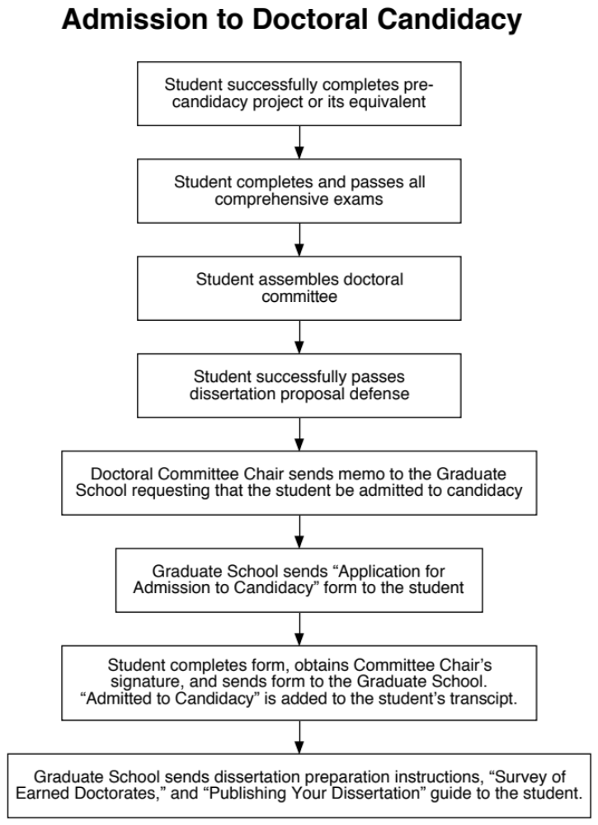

Procedures for Monitoring Doctoral Student Performance

Both the Graduate School and the I-O Program Committee actively monitor the progress of graduate students in meeting the requirements of their respective programs. Given the more extensive demands placed on doctoral students and the correspondingly lengthier timeline (5 years vs. 2 years), greater care is taken to monitor doctoral students' performance during their program of study. Two forms are used for this purpose, one issued by the Graduate School and one by the I-O Program. Both are due to the student's advisor by April 15.

Graduate Schools' Annual Report on Progress Toward Completion of Doctoral Degree

Each year, the doctoral student and his/her faculty advisor/dissertation chairperson prepare a brief summary of the student's progress toward completion of the doctoral degree by completing the form on the following pages. Once completed, the form must be forwarded to the Graduate School by May 1 and a copy placed in the student's file in the Psychology Graduate Program office.

Graduate School

REPORT ON PROGRESS TOWARD COMPLETION OF DOCTORAL DEGREE
Instructions: This form is due to your Program Advisor/Dissertation Chairperson no later than April 15th and to the Graduate School by May 1st. The original will be kept in your departmental file; a copy will be forwarded by your program to the Graduate School (Lorton Hall 201). The form must be complete and accurate or it will be returned by the Graduate School. Failure to submit a complete and accurate report may negatively impact your future enrollments, assistantships or fellowships.

Print Name _______________________________________________________________________________________________________ ID ________________________________
(Last) (First) (Middle)

Circle the appropriate program: English Language and Literature Biological Sciences Chemical Engineering
Clinical Psychology Computer Science Mechanical Engineering
Industrial/Organizational Psychology Geosciences Petroleum Engineering

1. Began doctoral program at TU: Fall Spring (circle one) ________ Year 2. Passed comprehensive/qualifying examination(s): Fall Spring (circle one) ________ Year

3. Defended dissertation proposal/prospectus: Fall Spring (circle one) _____ Year 4. Dissertation committee approved by Graduate School: Yes No I do not know. (circle one)

5. Dissertation Committee (please print):

Chairperson or Co-chair: _________________________________________________________ Other co-chair, if applicable: _______________________________________________

Committee Members: ____________________________________________________________ ____________________________________________________________________

Other committee member(s), if applicable: _____________________________________________ ___________________________________________________________________

Committee member(s) from outside TU or program, if applicable: ___________________________________________ ___________________________________________________

6. Projected date for completion of your dissertation: Fall Spring Summer (circle one) _________ Year

7. Official Leave of Absence, if taken: From __________________ to _______________________

Attach additional sheet if necessary to answer the following two questions.
8. What progress was made toward completion of your degree during the past year? (Do not include progress recorded in past report). Please explain any departures from last year’s goals.

9. Itemize the remaining requirements for completion of your degree and propose a timetable for completing them. Indicate which requirements you expect to complete during the next year. If you are in the writing stage of your dissertation, propose a detailed timetable for completion.

(Continued)
Questions to Be Completed by the Student’s Program Advisor or Dissertation Chairperson

1. Comment on the student’s progress toward degree completion during the last year.

2. Comment on the student’s proposed objectives for the next year.

3. Is the student’s timetable for completing the degree reasonable? Yes No Is the student’s projected date for dissertation completion realistic? Yes No
If the answer is no to either question, please explain.

I have met with the student to discuss her or his progress.

_________________________________________________________________________________________________ _____________________________________________
Signature of faculty member Date
___________________________________________________________________________________________________________________________________________________

Student’s reply to Advisor’s/Chairperson’s comments:

___________________________________________________________________________________________________ ____________________________________________
Signature of student Date

I-O Program Doctoral Student Annual Evaluation

The second form used to monitor doctoral student progress, this one issued by the I-O Program, is shown on the following pages. It is to be completed by the student and her or his advisor by February 15 each year. The completed form serves as a basis for individual student performance review by the I-O Program Committee in light of academic, ethical, and professional standards. The student’s current transcript, formal evaluation(s) from previous years, and available intern performance appraisals (pp. 61-62) may be considered in the evaluation. The completed form is retained in the student's file following IOPC review.

The evaluation form covers student performance in the following eight areas:

- coursework,
- pre-candidacy research,
- comprehensive examinations,
- doctoral research,
- other research (e.g., conference participation)
- fieldwork/internships,
- departmental citizenship, and
- professional / ethical conduct.

The I-O Program Committee records relevant information (e.g., GPA, stage of progress) and rates performance in each area, as well as overall, on a 1 (unsatisfactory), 2 (satisfactory), 3 (exemplary) scale. Comments, recommendations, and developmental goals are articulated, and an optional letter describing any specific difficulties and remedies may be appended to the evaluation. The advisor meets with the student within two weeks following IOPC review to discuss the review and, in particular, any remedial strategies and goals identified by the IOPC. A meeting with the entire IOPC may be requested by either the student or the advisor to discuss the evaluation, but is not required. The student signs and returns the evaluation to his or her advisor, who submits it to the Graduate Program Assistant for filing. It is the student's responsibility to ensure that factual statements (e.g., regarding research projects in which the student is actively involved) are accurate.

If a student has two years (consecutive or otherwise) in which the overall evaluation is unsatisfactory, the program committee will entertain a motion to recommend dismissal of the student from the program. The student and his or her advisor will be asked to speak to the committee on this issue before the vote.

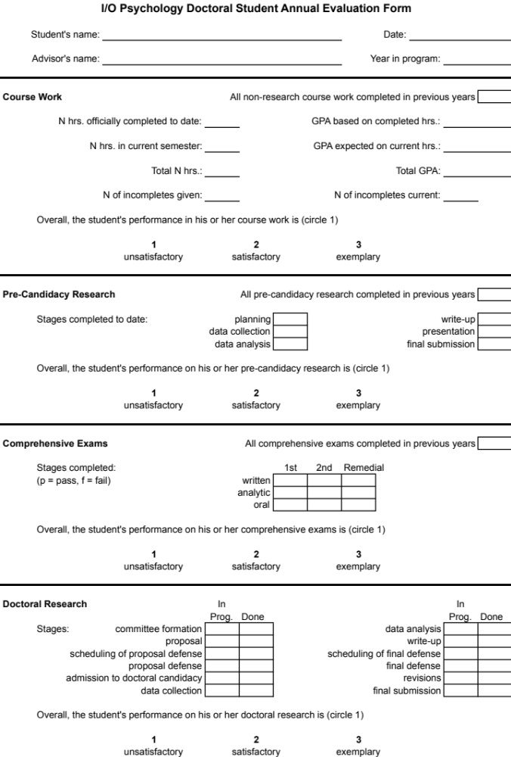
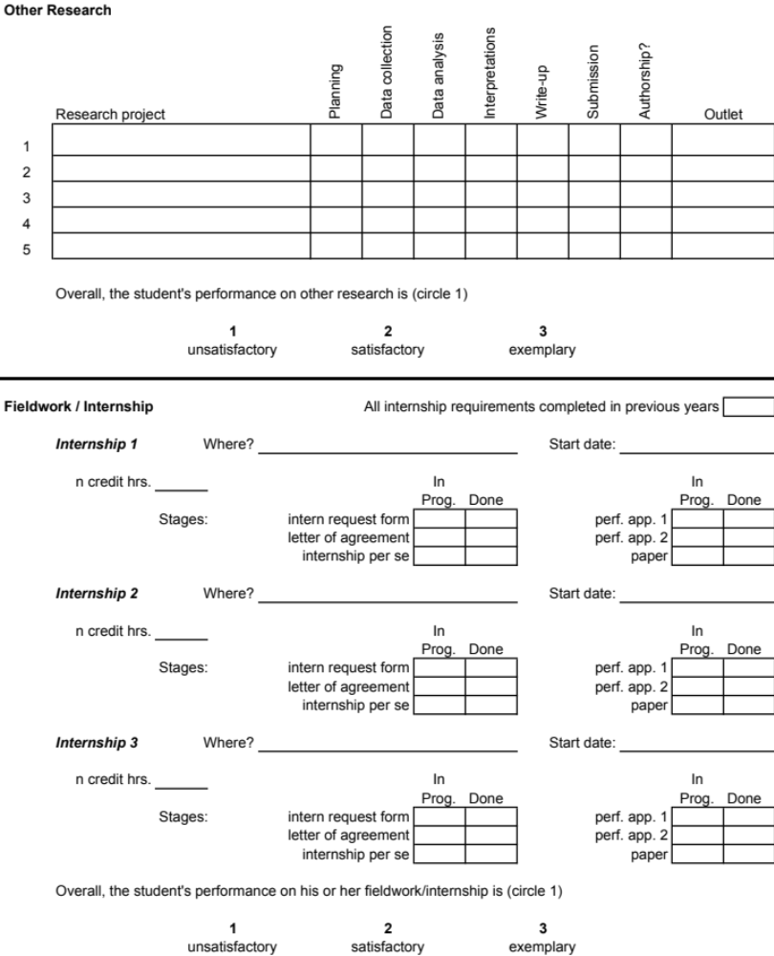

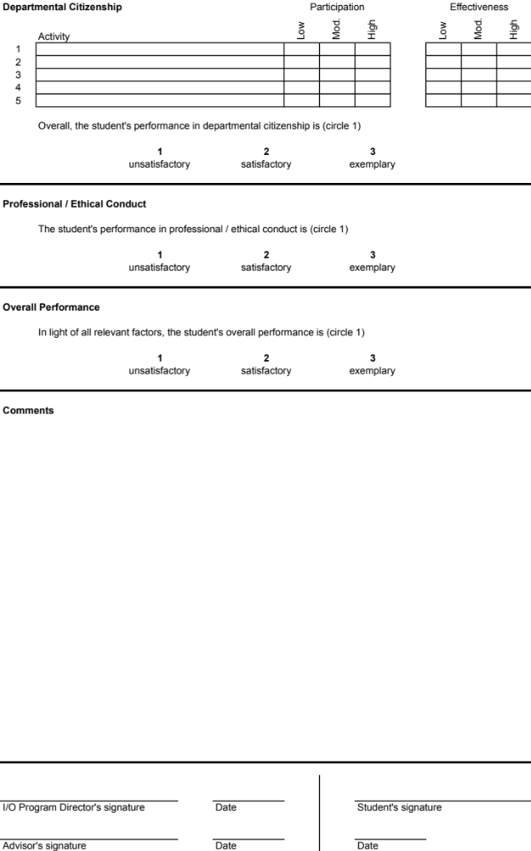

Doctoral Students Seeking the MA Degree

Ph.D. students are not required to obtain the MA degree, but some choose to do so for three reasons. First, Ph.D. students seek the MA because they believe it strengthens their resume and/or vita. Second, because of existing or expected performance deficiencies, some Ph.D. students may not be admitted to doctoral candidacy (see pp. 46-47) and so pursue an MA degree as a "back-up" plan. Third, the first two years of study for both the MA and Ph.D. are very similar. The only additional Ph.D. requirement due in Spring of Year 2 is the pre-candidacy project, and so doctoral students pursuing the MA en route need to allocate their time appropriately in light of this additional burden.

Doctoral students seeking the MA must satisfy all requirements of the MA program as described earlier in the Handbook (see MA balance sheet on p. 25). A summary of course requirements is offered below.

- Industrial-Organizational Psychology

Number of Credits 16
Courses Survey of I, Survey of O, Fieldwork (1 credit), plus 3 other approved I-O
courses

- Methods

Number of Credits 9
Courses Research Methods, Statistics II, Psychometrics

- General Psychology

Number of Credits 6
Courses Any 2 approved courses (must be from two different areas of psychology)

- General Electives

Number of Credits 6
Courses Any 2 approved electives

Total Number of Credits = 37

- Masters level comprehensive exams

Components written, analytic, oral

Offered Friday before the start of Spring semester classes

VI. Fieldwork in I-O Psychology (Internships)
_________________________________________________________________________________________________________________

Fieldwork Purpose and Requirements

What is the purpose of I-O fieldwork?

I-O psychologists must be able to effectively function in organizations. This requires interpersonal skills and an understanding of how to apply technical skills and theoretical knowledge in “real world” situations. We believe that these competencies are more effectively developed in actual organizations than in the classroom. Therefore, fieldwork experiences (also referred to as internships) are viewed as a critical element of the Masters and doctoral I-O programs.

What are the I-O fieldwork requirements?

To count for credit toward a psychology degree, students must register for PSY 7441. This course is administered by the Internship Coordinator (the Program Director or his/her delegate) who then serves as a University representative and an advocate/advisor for the student, should the need arise. PSY 7441 does not typically involve a classroom component although the Internship Coordinator reserves the right to include such a component. To qualify, an internship must entail at least 200 hours of actual fieldwork. This work may be distributed in any fashion that meets the needs of the student and/or the organization (e.g., five 40-hour weeks; ten 20-hour weeks).

All students in the I-O MA program (both basic and thesis-option) must complete a single 1-credit internship via enrollment in PSY 7441. All students in the I-O doctoral program must complete two 1-credit internships via two enrollments in PSY 7441 or a single 2-credit internship via enrollment in PSY 7442 (= 400 actual fieldwork hours). Doctoral students may take up to 3 credits of fieldwork (in PSY 7441-3).

Do I receive a grade for fieldwork?

Yes. The Internship Coordinator assigns fieldwork grades. Students receive a grade below “B” in I-O fieldwork only if performance has been unethical, irresponsible, or otherwise poor in the judgment of the on-site supervisor or I-O Program Director. A grade below a “B” in fieldwork will not count toward program requirements. Students who obtain a second grade below “B” in I-O fieldwork are not permitted to enroll for a third fieldwork experience and are unable to complete the I-O MA or PhD programs.

How are students matched with organizations?

Several local organizations utilize I-O interns on a regular basis. Each semester, the Internship Coordinator receives intern requests from these and other local organizations. Upon receiving an intern request, the Coordinator takes one of two actions. If the Coordinator knows of a particular student(s) who, in the judgment of the Coordinator, is (are) a good match for the position, the Coordinator may personally recommend the student to the organization. More often, the Coordinator forwards job postings to all eligible students as those advertisements are received by e-mail.

Do I have to be enrolled in course credit to arrange an internship?

No. Students frequently find internships before officially enrolling in the internship credits. Further, the dates of the internship do not have to perfectly correspond to the academic calendar. When a student has an opportunity to begin an internship in the middle of the semester, the student is encouraged to begin the internship and complete the credits during the next semester. Generally, students are not permitted to enroll in PSY 7441 prior to actually arranging a specific internship position.

Does the internship have to be a paid position?

No. The critical feature of the internship is the quality of experience it provides the student in areas relevant to I-O psychology. Whether or not paid compensation is offered is secondary. However, students are encouraged to seek paid internships, as payment confirms that the host organization values the I-O knowledge and skills the intern brings to the organization. Being paid is good not only for the student, but for the I-O psychology profession as well.
What is the best strategy for obtaining an internship?

Students are encouraged to be enterprising. They should attempt to establish a social network in the local professional community through involvement in professional organizations and to maintain an effective social network with their fellow students. Students should keep the following in mind:

- A voluntary position is an excellent way to obtain relevant experience.
- Both paid and voluntary positions sometimes lead to full-time permanent positions.
- Students are encouraged to begin searching for internships early in their program of study, although it is recommended that the internship begin no sooner than the summer after the first year.
- The internship does not have to be compensated and the I-O program is not obligated to find a compensated position for each student. If a student has difficulty obtaining an internship, the Internship Coordinator will assist the student in locating an internship.

Must the internship be in Tulsa?

No. Students are encouraged to find internships that best meet their professional development needs and aspirations. There are no geographical requirements or limitations. Thus, students planning to live in a specific geographical region are urged to seek an internship in that region.

Are there any forms to complete in arranging an internship?

Yes. The Internship Coordinator ensures that students are working in positions in which the primary job duties involve the practice of I-O psychology, broadly defined. The main concern is that the internship provides applied experiences beyond those required by a primarily clerical position. Before students are permitted to enroll in Fieldwork, the Internship Coordinator must receive an Intern Request Form completed by the on-site supervisor, describing the general type of I-O work that will be undertaken by the intern. If the Coordinator approves the overall focus of the internship, the student then arranges submission of a more detailed Letter of Agreement, describing the exact scope and nature of the proposed work, goals, deliverables, timelines, and contact information of the on-site supervisor. A job description may be appended for clarification. The Letter of Agreement must be submitted by no later than the end of first week of classes in the term in which the student is enrolled in Fieldwork, signed by both the on-site supervisor and student.

Is any form of performance documentation required?

Yes. Students must have their internship performance evaluated by his or her on-site supervisor and, if available, a second person familiar with the student's performance (e.g., a co-worker). Evaluations are made using a standard form (pp. 66-67) at both the 80-120-hour point (mid-term evaluation) and after 180 hours of internship work have been completed (final evaluation).

What information does the organization need to know?

The following sheet offers a guide on the I-O internship program that clarifies our expectations. Students may provide this information to any prospective internship supervisor/organization. We strongly encourage this, as it often helps to clarify program expectations and the expected functions of the intern.

Can the fieldwork requirement be waived?

Yes. The I-O internship requirement may be waived at the discretion of the I-O Program Committee for individuals who have extensive work experience in human resource management/personnel psychology. In these cases, the student substitutes an additional elective for PSY 7441, as described above.

What special concerns are there for international students?

The two most common internship issues for international students are language difficulties and visa-related work restrictions. International students with language difficulties should recognize that they may face challenges in locating a position until those language difficulties are resolved. Consequently, international students are encouraged to take additional credits of English coursework as required (these credits are not counted as part of the 37 hours required for the MA degree). International students also are expected to be responsible for resolving any visa-related issues that prevent them from receiving pay for an internship.

University of Tulsa

Organizations' Guide to the Industrial-Organizational

Psychology Fieldwork Program

The Program:

The University of Tulsa offers MA and Ph.D. degrees in Industrial and Organizational (I-O) psychology. These degrees prepare students to work in Human Resources Management or Organizational Development positions for companies, government agencies, labor unions, and consulting firms. Typical job duties of our graduates include:

Designing and evaluating systems for personnel selection, performance assessment, or compensation.
Administering surveys of employee attitudes, bargaining preferences, job stress, or working conditions.
Conducting research on organizational behavior, job satisfaction, and employee effectiveness.
Developing and evaluating organizational interventions (restructuring, training, culture change, etc.).

The Internship:

The purpose of the internship is to supplement students' classroom experiences with real-world experience directly related to industrial-organizational psychology. MA students are required to complete a single, 1-credit-hour fieldwork experience (i.e., internship) and Doctoral students are required to complete 2 to 3 such experiences. The total number of working hours per internship must be at least 200. Interns are required to work in an organization in a human resources management, personnel, or organizational development position.

Typical salary range:

Intern compensation typically ranges from $20 to $30/hr, depending on the skills required for the position and the education and experience of the student. Internships do not have to be compensated, but given the overall value of the services our students provide, most organizations offer compensation.

Hours/Week:

Completing 200 working hours could mean having to work 12-15 hours each week for a total of 15 weeks. The organization may hire the student for a longer period of time or for more hours, as needed. Further, the internship does not have to correspond exactly to the academic semester. So, an organization could, for instance, hire an intern for five 40-hour weeks or 20 ten-hour weeks.

Expectations:

We try to be flexible with the types of jobs that can count as I-O internship experiences. Our primary concern is that students do not serve mostly as clerical support staff. That is, we want students to get hands-on experience with human resource management tasks and issues. We recognize that clerical functions are required of most people and we expect our students to perform these functions when required by the organization.

Performance Documentation:

Students are required to submit a Letter of Agreement describing their duties, including the name and address of a contact person for the internship. Intern supervisors and a second person familiar with his or her performance will be asked to complete a short performance inventory concerning the intern both at the midpoint of the internship and at the end. Students are asked to evaluate the quality of the internship experience.

For further information, contact:

Robert P. Tett, Ph.D.
918-631-2737
robert-tett@utulsa.edu
University of Tulsa I-O Psychology Intern Request Form

Employer & Student Information:
- Company Name: | __________________________ | Student’s name: ________________ | ____________________________
- Contact Name: | __________________________
- Title for Contact Name: | __________________________
- Address: | __________________________(Street) | __________________________ (City/State) | ____________________________ (Zip Code)
- Phone number: | __________________________ | Email Address: | ____________________________

Position Description:
- Estimated time-frame for position: | Start date: ____________ | End date: __________
- What are the expected hours/week? | _____________________
- Compensation terms (e.g., $/hr.): | $____________________
- To whom will the intern report? | _____________________ | phone number: | ________________________
- Indicate amount of supervision/direct contact the intern will have with the person to whom he or she reports: | _____ daily | _____ weekly | _____ monthly (or less)
- Will anyone else be responsible for providing supervision or formal guidance to the intern? | _____ yes | _____ no
- If “yes”, please indicate who this person(s) is and the amount of supervision or guidance to be provided: | Name(s):  _____________________  _____________________ |  | Hours/week of supervision:  ________________________  ________________________
- Please indicate others with whom the intern will work on a regular basis (place an “x” next to all appropriate constituencies):  ____ internal customers (e.g., depts.;  work groups; senior management) | ____ external clients or customers | ____ personal work  group or team | ____other (specify)

Job Components:
- In which of the following areas will the intern be expected to work? (A separate Letter of Agreement detailing more specific goals, duties, tasks, and timelines will be requested at a later time, prior to the start of the internship.)

- Please indicate the primary area(s) in which work will be focused in this position: (check all applicable items)
____ personnel selection systems | ____ recruiting | ____ performance management
____ compensation/benefits | ____ survey development & admin. | ____ training & education
____ change management | ____ organizational design | ____ leadership development
____ research & validation | ____ organizational development | ____ career management
____ individual assessment | ____ other (please specify __________)

Students' Guide to the I-O Psychology Fieldwork Program

Main Guidelines
1. Internships (fieldwork) are required of both MA and Ph.D. students (1 and 2-3 credit-hours, respectively).
2. Arranging an internship is the responsibility of the individual student. The Internship Coordinator (the Program Director or his/her delegate) may assist in this effort, but should not be relied upon as the sole source of internship leads. A list of past I-O internship sites is maintained by the I-O program to assist students in finding a suitable internship.
3. Students must enroll in PSY 7441 to meet the Internship requirement. Students may unofficially begin an internship prior to the PSY 7441 semester, but must complete most of their internship work (i.e., at least 101 working hours) during the semester in which they are enrolled in PSY 7441.
4. A TU I-O Intern Request Form (p. 58 is to be (a) completed by the internship employer to clarify terms and responsibilities, and (b) approved by the Internship Coordinator before the student enrolls in 7441, preferably midway through the preceding semester. Exceptions may be approved by the Internship Coordinator.
5. The fieldwork experience must deal mostly with core I-O activities. (A list of appropriate activities is included at the bottom of the TU I-O Intern Request Form.) Jobs entailing a lot of clerical duties are not proper I-O internships. Students who find themselves doing mostly non-I-O work on their internships should first attempt to resolve the situation with the internship employer, in light of terms specified in the Intern Request Form. If the scope of duties cannot be resolved with the employer, the student is advised to contact the Internship Coordinator as soon as possible.
6. Working with the prospective host organization, the student must develop and submit a 1-2 pp. Letter of Agreement specifying the nature of the work to be completed during the internship. The purpose of the Letter is to ensure all parties (student, host organization, Internship Coordinator) agree as to the scope and nature of the expected duties, timelines, and deliverables. This, in turn, allows confirmation that the internship duties are appropriately I-O-related, and provides a basis for evaluating the intern’s performance. The Letter must be submitted no later than the end of the first week of the PSY 7441 semester and must be approved by the Internship Coordinator. Earlier submissions are recommended (e.g., a month before the start of the PSY 7441 semester) to allow time for revisions (e.g., regarding the scope or nature of a project) or, in some cases, procurement of an entirely new internship. Key contents of the Letter of Agreement are described on the next page.
7. Interns must complete 200 hours of fieldwork per single hour of internship course credit.
8. Students are to be evaluated at two points during their internships. A mid-term evaluation is to be undertaken when the intern has completed between 80 and 120 hours of internship work (out of a total of 200 hours), and the second evaluation, following 180 hours of internship work. Both evaluations are to be undertaken by the intern’s immediate on-site supervisor and, if available, a co-worker with whom the intern has worked closely. The TU I-O Intern Evaluation Form can be found on pp. 61-62. The student/intern is responsible for making and distributing copies of the form to each rater. Raters are to submit completed forms directly to the Internship Coordinator either by regular mail, e-mail, or fax. Raters have the opportunity at the bottom of the form to indicate whether or not they will allow the intern to see the completed evaluation. Students who wish to review completed evaluations should ask the Internship Coordinator.
9. For internships undertaken during Spring and Fall terms, there is no class attendance requirement. For internships undertaken during the Summer term(s), there may be a class attendance requirement. See the Internship Coordinator for details regarding the given Summer term. If you start an internship in the middle of Spring term, you must enroll in 7441 for the following Summer term and abide by any course requirements (e.g., class attendance) assigned that Summer term.
10. All students, regardless of whether they are enrolled in the Fall, Spring, or Summer terms, are required to write a 8-10 pp. paper describing their internship experience and how it has furthered their development as a scientist-practitioner, or on a topic approved by the Internship Coordinator. Other requirements may be imposed at the discretion of the Internship Coordinator.
11. At the end of the internship, the student/intern is asked to complete a TU I-O Intern Site Evaluation Form (see pp. 63-64) and submit the completed form to the Internship Coordinator. The purpose of this form is to facilitate other students’ judgments of possible fit in future internships at that site.
12. MA students may enroll in only 1 hour of Fieldwork credit (this applies to those in the Thesis Option). Working hours per 1-credit internship (i.e., 7441) may be spread out over one or two semesters. In the latter case, enrollment must be in the semester in which the bulk of the internship is undertaken (i.e., >100 working hours of the required 200).
13. (For Doctoral students only:) A separate Letter of Agreement is required for each semester in which the student is enrolled in 7441-3. Performance also must be evaluated, as per point 8, on a per enrollment basis. Thus, a student enrolled in PSY 7441 in two consecutive semesters will be evaluated at the middle and end of each semester. The raters may or may not be the same individuals in the two evaluation cycles.
14. Letter grades are assigned based on (a) submission of a completed Intern Request Form, (b) preparation and submission of a Letter of Agreement, (c) submission of completed performance evaluation forms from the intern’s on-site supervisor and, if available, a co-worker familiar with the intern’s work, (d) favorable performance evaluations in light of expectations specified in the Letter of Agreement, and (e) submission of an 8-10 pp. paper describing the internship experience.
15. A letter grade of C, D, or F will not be accepted as fulfilling the internship requirement. Such grades may be awarded for failure to submit required documentation (e.g., Letter of Agreement) and in extreme cases of failing to meet expectations and/or lack of professionalism in undertaking designated internship duties.

Letter of Agreement

Key elements of the letter of agreement should include: (a) site address; (b) on-site supervisor contact information and relevant qualifications (e.g., Masters in HR Management; 5 years experience as Personnel Director); (c) a list of targeted internship projects, assignments, goals, timelines, and related duties; (d) an existing job description, (e) reference to any binding employment documents furnished by the site organization (e.g., employment contracts, non-disclosure agreements); and (f) expectations regarding use of organizational data (e.g., personnel records) for research purposes. The Letter of Agreement is the responsibility of both the organization and the intern and both parties are expected to play an active role in its creation. As per point 6, above, the Letter must be submitted no later than the end of the first week of the PSY 7441 semester and must be approved by the Internship Coordinator no later than a week following enrollment (preferably before).

Summary of Order of Operations in Arranging and Completing an Internship

1. Identify a prospective internship site (e.g., for a summer internship, by early-April, preferably sooner). Offer the Organizations’ Guide (p. 57 to potential host organizations as part of the search process.
2. Have the prospective host organization complete the Intern Request Form and submit it to the Internship Coordinator for approval (by mid-April). The Form could be attached to the Organizations’ Guide in step 1.
3. On approval of the Intern Request Form, work with the host organization to create a Letter of Agreement. Submit the Letter of Agreement to the Internship Coordinator for approval (by late-April). Make edits in light of any feedback.
4. On approval of the Letter of Agreement, enroll in PSY 7441 (the last digit denotes the number of credit hours). Typically, students enroll prior to the start of semester classes. Exceptions may be made, especially for summer internships, permitting rolling enrollment.
5. Arrange evaluation of intern performance by the immediate supervisor and a co-worker, at the 80-120-hour mark of the internship (mid-term evaluation). Have the completed evaluation forms sent directly to the Internship Coordinator (e.g., by e-mail).
6. Arrange evaluation of the intern’s performance by the immediate supervisor and a co-worker, at the 180-200-hour mark of the internship (final evaluation). Have the completed evaluation forms sent directly to the Internship Coordinator (e.g., by e-mail).
7. Once 200 hours are finished, complete the Internship Site Evaluation Form (optional) and an 8-10 pp. paper describing the internship experience (required) and submit them to the Internship Coordinator.
University of Tulsa Year: _________
I-O Psychology Intern Evaluation Form Mid-term  Final 

Intern's name: ________________________________________ Student program: MA  PhD 

Internship site: ________________________________________ Semester: Fall  Win  Spr  Sum 

Rater's name (print): ___________________________________ Rater is intern's supervisor  co-worker 

Title: ________________________________________________ Phone: (______)_____________________

Evaluation period: from _____/_____/_____to_____/_____/_____ Today's date: ______/______/______

Overall, how familiar are you with the intern's performance? somewhat  moderately  highly 

About how many hours of work has the intern completed to date as part of his/her internship? __________

Rating Instructions

Ten dimensions are listed below (and over) for judging the intern's performance. Please provide two ratings for each dimension. First, rate the level of the job's demand for effective performance in the given area using the "Job Demand" scale. Second, rate the intern's performance in that area using the "Intern Performance" scale. For each rating, print the appropriate number in the space provided at left. If you are unable to offer a rating, print "U". Space is available at right for comments regarding each dimension.

Job Demand

0 1 2 3 4 U
none slight moderate considerable high unable to rate

Intern Performance (relative to minimum required level)

0 1 2 3 4 U
well below somewhat at the somewhat well above unable
minimum below minimum minimum above minimum minimum to rate

Job Intern Comments
Dem. Perf.

(1) Job Knowledge (consider:)

• Knowledge of I-O psychology practice (e.g., job analysis, selection, training)
• Application of relevant knowledge to assigned tasks

(2) Professionalism (consider:)

• Professional demeanor, presentation, dress
• Ethical practice

(3) Oral Communication (consider:)

• Quality of communication with clients and co-workers
• One-on-one or small group discussions
• Public presentation of projects / reports continued . . .
Job Intern Comments
Dem. Perf.

(4) Written Communication (consider:)

• Clarity and accuracy of written expression
• Reports, letters, office memos, e-mail

(5) Motivation and Initiative (consider:)

• Positive work attitude
• Willingness to work hard
• Eagerness to learn

(6) Stress Tolerance (consider:)

• Management of workload without excessive complaining
• Handling of multiple and/or conflicting assignments
• Dealing with uncertainty

(7) Cooperation (consider:)

• Working with others
• Meeting others' requests
• Concern for clients' and co-workers' well-being

(8) Dependability (consider:)

• Following instructions
• Timeliness in completing projects
• Punctuality and attendance

(9) Adaptability (consider:)

• Flexibility in meeting changing work demands
• Tolerance of others' ideas
• Creative thinking

(10) General Work Skills (consider:)

• Planning and organizing
• Understanding instructions
• Independent problem solving

What areas of improvement should the intern/student focus on in future training?

Additional comments that might aid in the evaluation and training of the intern/student:

Rater's signature: ______________________________________

I do  / do not  grant permission to allow the intern to see this evaluation.
University of Tulsa Year: ___________
I-O Psychology Internship Site Evaluation Form

Intern's name: ________________________________________ Student program: MA  PhD 

Internship site: ________________________________________ Semester: Fall  Win  Spr  Sum 

Evaluation period: from _____/_____/_____to_____/_____/_____ Today's date: ______/______/______

Rating Instructions

Ten dimensions are listed below (and over) for describing your internship experience. Please provide three ratings for each dimension. First, rate what you see as the Ideal level based on your own preferences. Second, rate the Actual level based on your internship experience. Note that rating the Actual level above Ideal means the internship overshot your preference, and rating the Actual level below Ideal means it fell short in that respect. Finally, rate the Importance of the Gap between Ideal and Actual levels. Thus, if it is important to you that the Actual level falls near the Ideal level, you might rate that dimension as a 4, 5, or 6 on Importance. Note that a high Ideal rating does not by itself imply high Importance. It might be very important to you (i.e., 6 on Importance) that the Actual level falls at an Ideal level of 3 (or some other value). Alternatively, the Ideal might be 6, but it may matter little to you whether the Actual level is 6, 5, 4, or some other value. Space is provided at right for comments regarding each dimension.

Ideal Level

1 2 3 4 5 6
very low moderately low slightly low slightly high moderately high very high

Actual Level

1 2 3 4 5 6
very low moderately low slightly low slightly high moderately high very high

Importance of the Gap

1 2 3 4 5 6
not at all slightly somewhat moderately considerably very
important important important important important important

Ideal Actual Imp. Comments

(1) Workload (consider:)

• the amount of work expected to be completed in a given time period
• pressure to complete tasks well, accurately, thoroughly, quickly

(2) Relevance to IO Psychology (consider:)

• the nature of the work as requiring knowledge of I-O principles and practices
• e.g., job analysis, selection, training, perf. appraisal, leadership, motivation, job attitudes

(3) Task Structure (consider:)

• clarity of work objectives, timelines, and instructions
• how often work progress is monitored continued . . .
Ideal Actual Imp. Comments

(4) Autonomy (consider:)

• expectations to work without supervision, set own goals, evaluate own progress
• expectations to be self-motivated

(5) Supervisor's Accessibility (consider:)

• the degree to which your supervisor is available for discussing work-related issues
• your supervisor's willingness to speak with you about your assignments

(6) Coaching / Mentoring (consider:)

• frequency and quality of developmental feedback provided by your supervisor
• availability of others to "show you the ropes" when needed

(7) Teamwork (consider:)

• expectations to be relied upon by co-workers and to rely on them in group projects
• working closely with others in team projects

(8) Respect from Others (consider:)

• how much your supervisor and co-workers show appreciation for your expertise
• how well your ideas are received by others; courtesy shown when your views are rejected

(9) Friendliness / Acceptance (consider:)

• how much others make you feel welcome
• support from others on work-related issues and otherwise

(10) Co-Worker Competence (consider:)

• the expertise of your co-workers in doing work affecting your own productivity
• co-workers' abilities to understand and implement supervisors' instructions

What aspects of the internship do/did you appreciate most and why?

What aspects of the internship do/did you appreciate least and why?

What sort of student do you feel would thrive best in this internship?

Overall, how would you rate your internship experience? (circle one)

1 2 3 4 5 6
very moderately somewhat somewhat moderately very
unsatisfactory unsatisfactory unsatisfactory satisfactory satisfactory satisfactory

Intern's signature: ______________________________________

I do  / do not  grant permission to allow my on-site internship supervisor to see this evaluation.

VII. Professional Development
_________________________________________________________________________________________________________________

Principles of Professional Involvement

- As a member of a profession, you have a responsibility to contribute to developments in I-O psychology.
- As a member of an organization, you have a responsibility to stay abreast of current issues in I-O psychology to better serve your clients and constituencies.
- As an individual seeking opportunities for advancement, it is in your interest to build and maintain social contacts in your profession at both the local and national level.

Professional Organizations and Conferences

The organizations listed below have discount rates (or are free) for student members. Each organization holds a national/local convention. These conventions are an excellent source of information regarding current developments in I-O research and practice and are excellent networking opportunities. Further, most of these organizations provide members with free or discounted rates to professional journals, newsletters, placement services, and other professional information. Most of these organizations also have web sites at which further information is available.

- National Organizations
- Academy of Management
- American Psychological Association (APA)
- American Psychological Society (APS)
- Industrial Relations Research Association (IRRA)
- Society for Human Resource Management (SHRM)
- Society for Industrial and Organizational Psychology (SIOP)
- American Society for Training and Development (ASTD)

- Regional/Local Organizations
- Southwestern Psychological Association (SWEPA)
- Tulsa Area Human Resource Association (TAHRA - local professional chapter of SHRM)

- University of Tulsa Student Groups
- APAGS - The Graduate Student Organization of APA
- GRASP - Graduate Association of Students in Psychology
- Student Chapter of TAHRA
- Toastmasters

- Student Conferences
- Academy of Management Doctoral Consortium
- Industrial Psychology/Organizational Behavior Graduate Student Conference
- SIOP Masters Consortium
- SIOP Doctoral Consortium

41 Useful Research Journals for I-O Psychologists

A list of the most widely known journals in various fields related to I-O psychology is presented below. It is not meant to be comprehensive and may not reflect holdings in the library at the University of Tulsa, although virtually all of the journals listed below are available on-line through the McFarlin Library. The list includes most of the journals that are useful for conducting an initial literature review.

- Academy of Management Executive
- Academy of Management Journal
- Academy of Management Review
- Annual Review of Organizational Psychology and Organizational Behavior
- Applied Psychology: An International Review
- Applied Psychology: Health and Well-being’
- Administrative Science Quarterly
- American Psychologist
- Human Performance
- Human Relations
- Human Resource Management Review
- Industrial and Labor Relations Review
- Industrial Organizational Psychology: Perspectives on Science and Practice
- International Journal of Selection and Assessment
- International Review of Industrial and Organizational Psychology
- Journal of Applied Psychology
- Journal of Applied Social Psychology
- Journal of Business and Psychology
- Journal of Management
- Journal of Managerial Psychology
- Journal of Occupational Health Psychology
- Journal of Occupational and Organizational Psychology
- Journal of Organizational Behavior
- Journal of Personality and Social Psychology
- Journal of Personnel Psychology
- Journal of Research in Personality
- Journal of Vocational Behavior
- Leadership Quarterly
- Military Psychology
- Organizational Behavior and Human Decision Processes
- Organizational Dynamics
- Organizational Psychology Review
- Organizational Research Methods
- Personality and Individual Differences
- Personnel Assessment and Decisions
- Personnel Psychology
- Psychological Assessment
- Psychological Bulletin
- Psychological Methods
- Psychological Review
- Stress and Health

Appendix A
Changes From Previous Handbooks

The Handbook is reviewed each year in light of evolving demands, experiences in applying program policies, and Graduate School initiatives. Changes in or clarification of rules and procedures implemented in previous years are described below. Policy changes do not automatically apply to students who began the program in previous years; applicable rules and procedures are those in place when the student began their I-O graduate training at TU. (See earlier handbooks for older rules and procedures.) The changes noted below are especially relevant to incoming students, who will be held to the rules and procedures described herein.

Changes Introduced in 2011

1. The addition of this Appendix, recording Handbook updates.
2. Clarification of the distinction between transfer credits and applied credits from graduate work completed elsewhere.
3. Comprehensive exams:
a) The analytic and oral exams are now described as being graded on an overall 0-to-3 scale, clarifying that scoring criteria are not applied per question, as in the case of the written exam.
b) The analytic exam is now described as an “open-book” exam.
c) For the written exam, students may bring a list of up to 100 references.
d) As an option to outright failure, a “conditional pass” is now described, entailing completion of a take-home remedial assignment targeting specific gaps in the student’s knowledge.
4. Fieldwork: Exceptions are acknowledged to the general policy that students are expected to enroll in internship prior to the start of semester classes. Rolling enrollment is permitted, especially for summer internships.

Changes Introduced in 2012

1. A space was added to the Intern Request Form for the student’s name. The title of the first box on the form was changed accordingly to “Employer and Student Information.”
2. The years of program directorship for the five I-O Program Directors since 1995 were added.
3. Clarification of Timing of Admission to Doctoral Candidacy
a) It was clarified that students are not admitted to doctoral candidacy until after they have successfully completed their dissertation proposal defense. Note: The rule did not change; rather, the rule was incorrectly excluded from previous editions of the Handbook.
b) A corresponding recommendation was added to the effect that students should seek to assemble their doctoral committees in the early stages of proposal preparation to give committee members the chance to help guide the project’s development.
4. The three stages identified as part of the dissertation process was expanded to include six stages. In keeping with the first point, “Admission to Candidacy,” now the fourth stage, was positioned to follow the proposal defense.
5. Some sections describing the Dissertation process were reordered in light of the clarification described in point 1 and otherwise to improve flow.
6. The figure describing admission to doctoral candidacy was modified in light of the changes noted in points 1 to 3.

Changes Introduced in 2013

1. Following detailed internal review (by the I-O Committee) and evaluation and approval by the Graduate Council in spring, 2013, the I-O Masters Program total credit hour requirement was reduced from 42 to 37, effective summer semester. The 5-credit drop is the sum of

a) a 3-credit drop under I-O coursework, allowing students to forego enrolling for a summer course and thereby to pursue richer summer internship opportunities (e.g., outside Tulsa), and

b) a 2-credit drop owing to reduction from 3 to 1 in internship credit hours. The minimum requirement of 200 working hours and all other definitive aspects of the fieldwork experience are completely retained. Notably, MA students are not permitted to enroll in more than one internship, dropping from the maximum of two per previous editions of the MA Handbook.

The combined 5-credit-hour drop makes the TU I-O program more competitive with similar programs in the US, the mode for which is 36 total credit hours.

Notably, the Ph.D. program retained the 90-credit-hour requirement so as to afford graduates the opportunity to seek licensure in the State of Oklahoma, which requires completion of a 90-hour degree. The 3-to-1 drop in credit-hours per internship means a drop from 6 to 2 as a minimum number of required internship hours for Doctoral students and a drop from 9 to 3 as the maximum. These differences (4-6 hours) are to be made up in research hours. To accommodate the drop in internship credit-hours, the maximum research hours was increased from 21 to 25. These changes are reflected in the Ph.D. balance sheet.

2. The MA balance sheets (regular and thesis-option) reflect the noted change from 42 to 37 credit hours. They also include updated course options and course numbers within major sections. The MA/JD program requirements remain unchanged in all respects.

3. The Ph.D. balance sheet (p. 21) includes updated course options and course numbers within major sections.

4. The cover page added the names of all active I-O committee members, in addition to the Program Director.

5. As in previous editions, minor changes were made throughout the document to increase clarity.

Changes Introduced in 2014

1. The I-O MA and Ph.D. Milestone Completion Records and their introductory summaries were amended to remove the signature requirement. The reason is that students have been progressing well enough over the past few years without the formality of signatures. Students are urged, nonetheless, to maintain their program-specific form on their own to help ensure timely completion of program requirements. The I-O Program Director reserves the right to require signatures on a case-by-case basis.

2. A section on professionalism was added, covering three specific subtopics: follow-through, respect, and rumors, gossip, and discretion.

3. Reference to "I/O" was replaced with "I-O" throughout the Handbook to be consistent with how SIOP abbreviates "industrial-organization psychology."

4. Dr. David Fisher (DePaul University) joins the I-O graduate program as a tenure-track Assistant Professor, raising the number of core I-O faculty at TU to five for the first time in the program's history.

5. Drs. Brummel and Narayan enter fall 2014 as Associate Professors, and Dr. Tett, as (full) Professor, having been promoted during the 2013-2014 academic year.

Changes Introduced in 2015

1. The two Program Handbooks (MA and Ph.D.) were merged into a single document because of their substantial overlap and to facilitate students' awareness of the commonalities and distinctions between program requirements.

2. The program underwent a detailed Self-Study in the 2014-2015 academic year, under the auspices of the Graduate School. (Dr. Alan Witt from the University of Houston served as the external reviewer.) The self-study document yielded new material suitable for selected sections in the Handbook (e.g., University and Program mission statements and their comparison, articulation of degrees conferred, description of the three main types of graduate assistantship). These sections were modified slightly in light of their specific functions in the Handbook.

3. Brief descriptions of the roles of two administrative assistants (Departmental and Graduate Program) were added as they relate specifically to management of the I-O Program.

4. Several major sections (e.g., academic, ethical, and professional guidelines) were reorganized to improve flow.

5. Excerpts from the Graduate Bulletin were updated to reflect changes in that source document undertaken by the Graduate School.

6. The enrollment process is described in greater detail in light of the availability of both enrollment cards and online enrollment. (Both options have been available for some time; just the description was updated.)

7. Forging documents was added to the list of unethical student behaviors (e.g., plagiarism) warranting potentially serious penalties.

8. References to external ethical guidelines were updated.

9. Conditions affecting judgment of the number of credits a student can apply from an earlier MA degree toward meeting Ph.D. requirements were clarified in terms of (1) relevance to I-O psychology, and (2) TU branding.

10. The term "core" was dropped from "I-O Core Courses" and "General Psychology Core Courses" on all the balance sheets and in the main text of the document in deference to Graduate School policy to reserve that term to denote required courses only. Required courses here are identified simply as "required courses" or by being printed directly on the left side of a given balance sheet. To be clear, what is considered a required course per program remains unchanged.

11. The rationale for requiring comprehensive exams was augmented by articulation of purposes: (1) to serve as a capstone assessment in protecting the integrity of a TU I-O degree (relevant to both the MA and Ph.D.), and (2) to prepare students for the dissertation (relevant to Ph.D. students only).

12. A paragraph was added to the end of the sections on comprehensive exams, clarifying that the I-O faculty is committed to fairness in exam coverage and grading. (Separate sections on comps were retained per MA and Ph.D. programs despite their overall similarity to minimize opportunity for confusion regarding critical distinctions.)

13. A third reason was added to why doctoral students might seek the MA degree en route to the Ph.D.: completing MA comprehensive exams offers excellent preparation for doctoral-level exams offered just 9 months later.

14. The low end of the typical pay range for internships was raised from $12 to $15 in light of inflation.

15. As in previous editions, minor changes in text and formatting were made throughout the document to increase clarity and consistency. Especially important points were reformatted in bold italics to increase their salience to the reader.

Changes Introduced in 2016

1. Program Competencies

a) Updated SIOP competencies were issued in Spring, 2016. The program's competency list was revised accordingly (p. 23).

b) "Core I-O Domains" have been reorganized under three sub-headings: General, I Psych, and O Psych.

c) Occupational Health & Safety has been moved from "Related Topics" to "O Psych" and the new SIOP competency "Human Performance" has been moved to "I Psych."

2. Both the "I-O MA Milestone Completion Record" (formerly p. 29) and "I-O Ph.D. Milestone Completion Record" (formerly p. 37) have been removed due to lack of use. Corresponding description on p. 24 was also dropped.

3. A small correction was made in describing the MA/JD program (pp. 29-30). Specifically, the addition of 1 credit hour to the MA/JD track for I-O fieldwork (internship) prior to 2015 resulted in the total number increasing from 111 to 112. This change brings the text into alignment with the balance sheet.

4. Comprehensive Exams

a) A major change was made in the doctoral exam (ratified in Spring 2016): it now has 2 stages, with Stage 1 = MA comprehensive exam, Stage 2 = doctoral-level written exam (see pp. 38-39).

b) Targeted competencies for the MA written exam (p. 31) have been updated in light of the SIOP 2016 competency list (see p. 23). Specifically, (i) in addition to updating labels, (ii) Professional Skills was added to Ethical, Legal, Diversity & International Issues in Question 1; (iii) Human Performance was added to Criterion Theory and Development for question 2, (iv) Occupational Health & Safety was added to the O Psych list (new Question 12), and, in making room for Occ Health, (v) Organizational Theory and Organizational Development were combined in Question 11.

c) Top of p. 32: competencies targeted by the analytic exam were reduced from four to three, given that the new SIOP competencies clarify "Individual Differences" includes psychological measurement (i.e., psychometrics & scale development).

d) The Doctoral benchmarks and timeline summary has been updated in light of the new doctoral comps procedure (p. 35).

5. In description of the I-O program doctoral student annual evaluation (p. 50), the deadline is now specified as February 15.

6. The Doctoral Re-specialization Program was officially terminated in Spring 2016 (see p. 59 in prior editions of the Handbook).

7. Funding expectations are now articulated on p. 17, following description of the three main GA types.

8. "SIOP Doctoral Consortium" was added to the list of student conferences on p. 65.

9. The list of journals relevant to I-O was updated (p. 66), expanding to 41 from 25 (APA Monitor was dropped).

Students are expected to maintain clarity in their understanding of all assignments (course, lab, internship, assistantship) and to seek clarity quickly, as needed, from instructors, advisors, and supervisors.
Almost always starting with a faculty advisor or the I-O Program Director.

